CHAT-ALL APPLICATION

(Final Project for DevOps)

Submitted by:

Shashank Sharma

Prashant Singh

This project encompasses 3 modules:

1. aws-eks-terraform: contains terraform scripts to create kubernetes cluster on AWS-Elastic-Kubernetes-Service.
2. client: front end for the application based on Angular framework
3. server: backend for the application based on ExpressJS and node.js framework

The steps are detailed below:

1. Github Checkout

Go to the GitHub URL for the project:

[*https://github.com/shanks2710/chatall_app*](https://github.com/shanks2710/chatall_app)

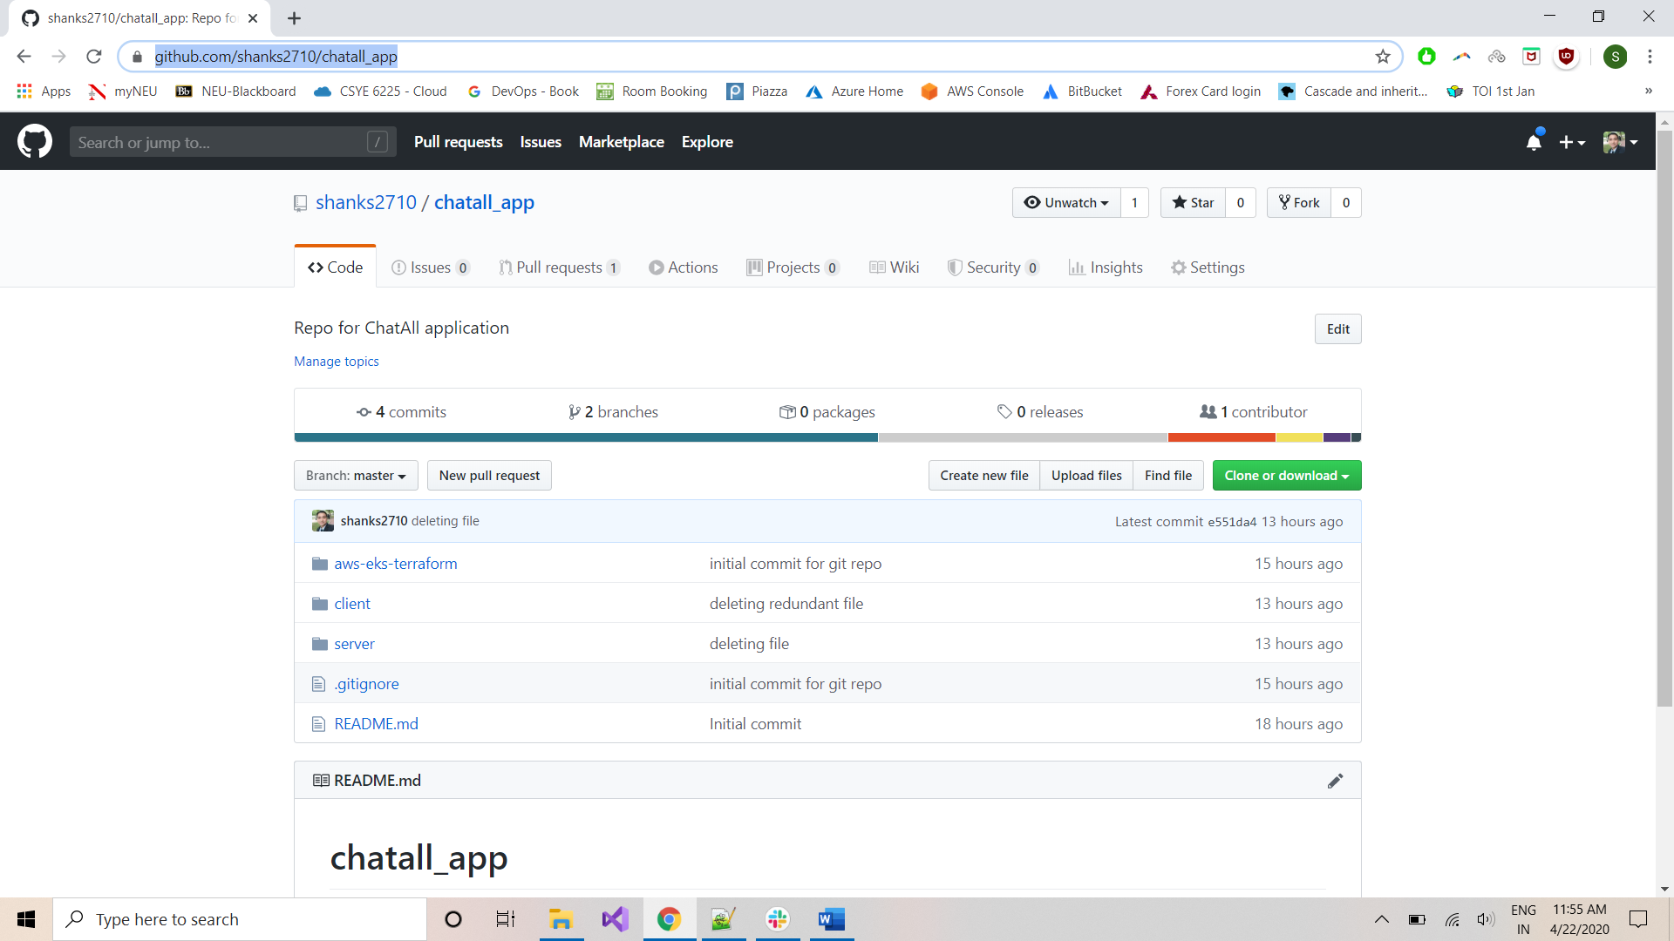

Click on ‘Clone or download’ button and copy the HTTPS URL: [*https://github.com/shanks2710/chatall_app.git*](https://github.com/shanks2710/chatall_app.git)

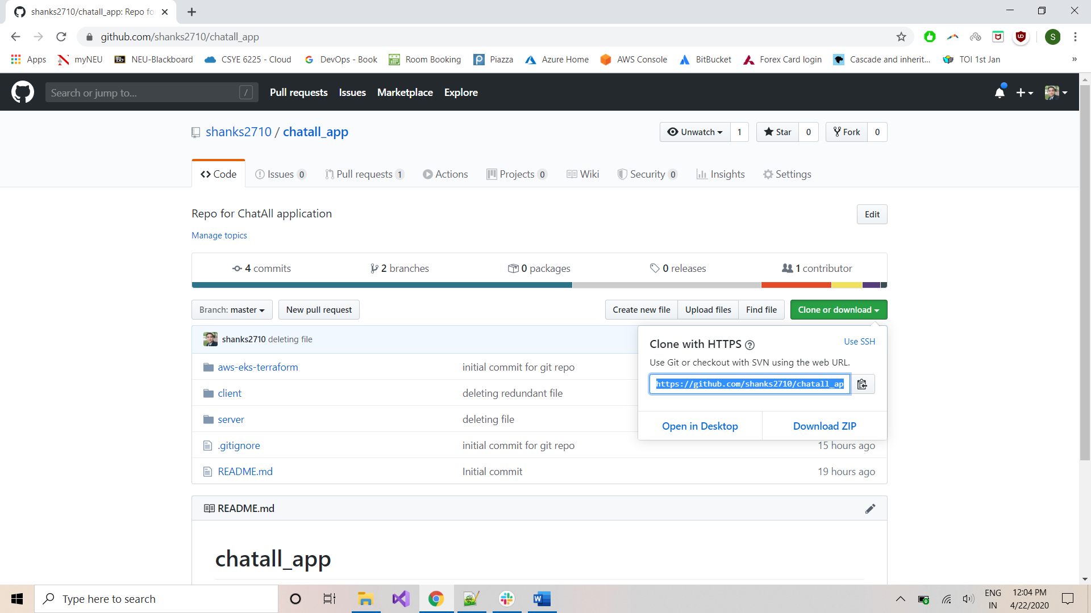

Create a folder on your machine and name it ‘DevOps_FinalProject’:

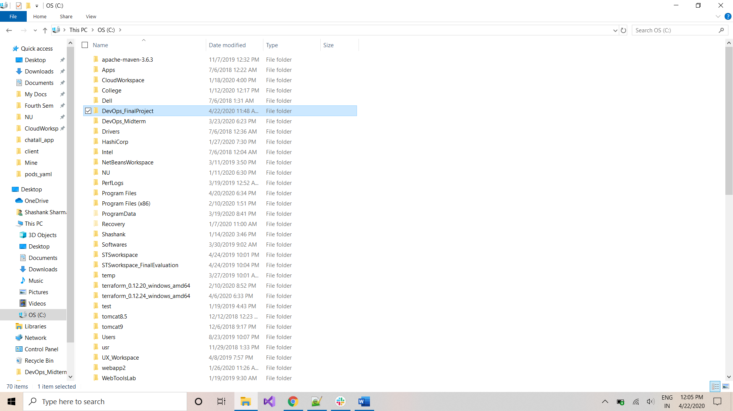

Open the folder and right-click to open *GitBash*:

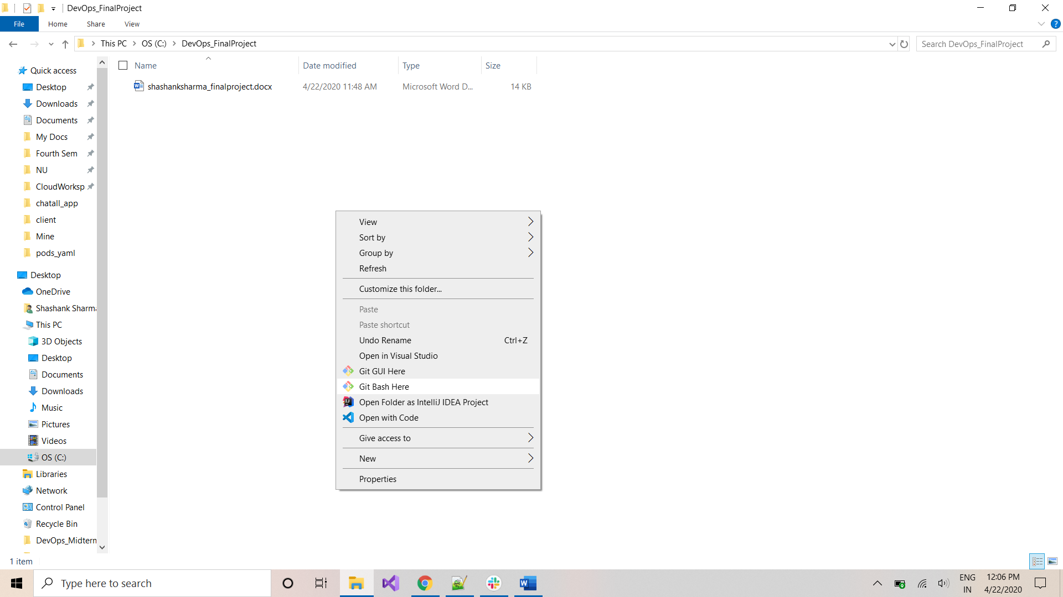

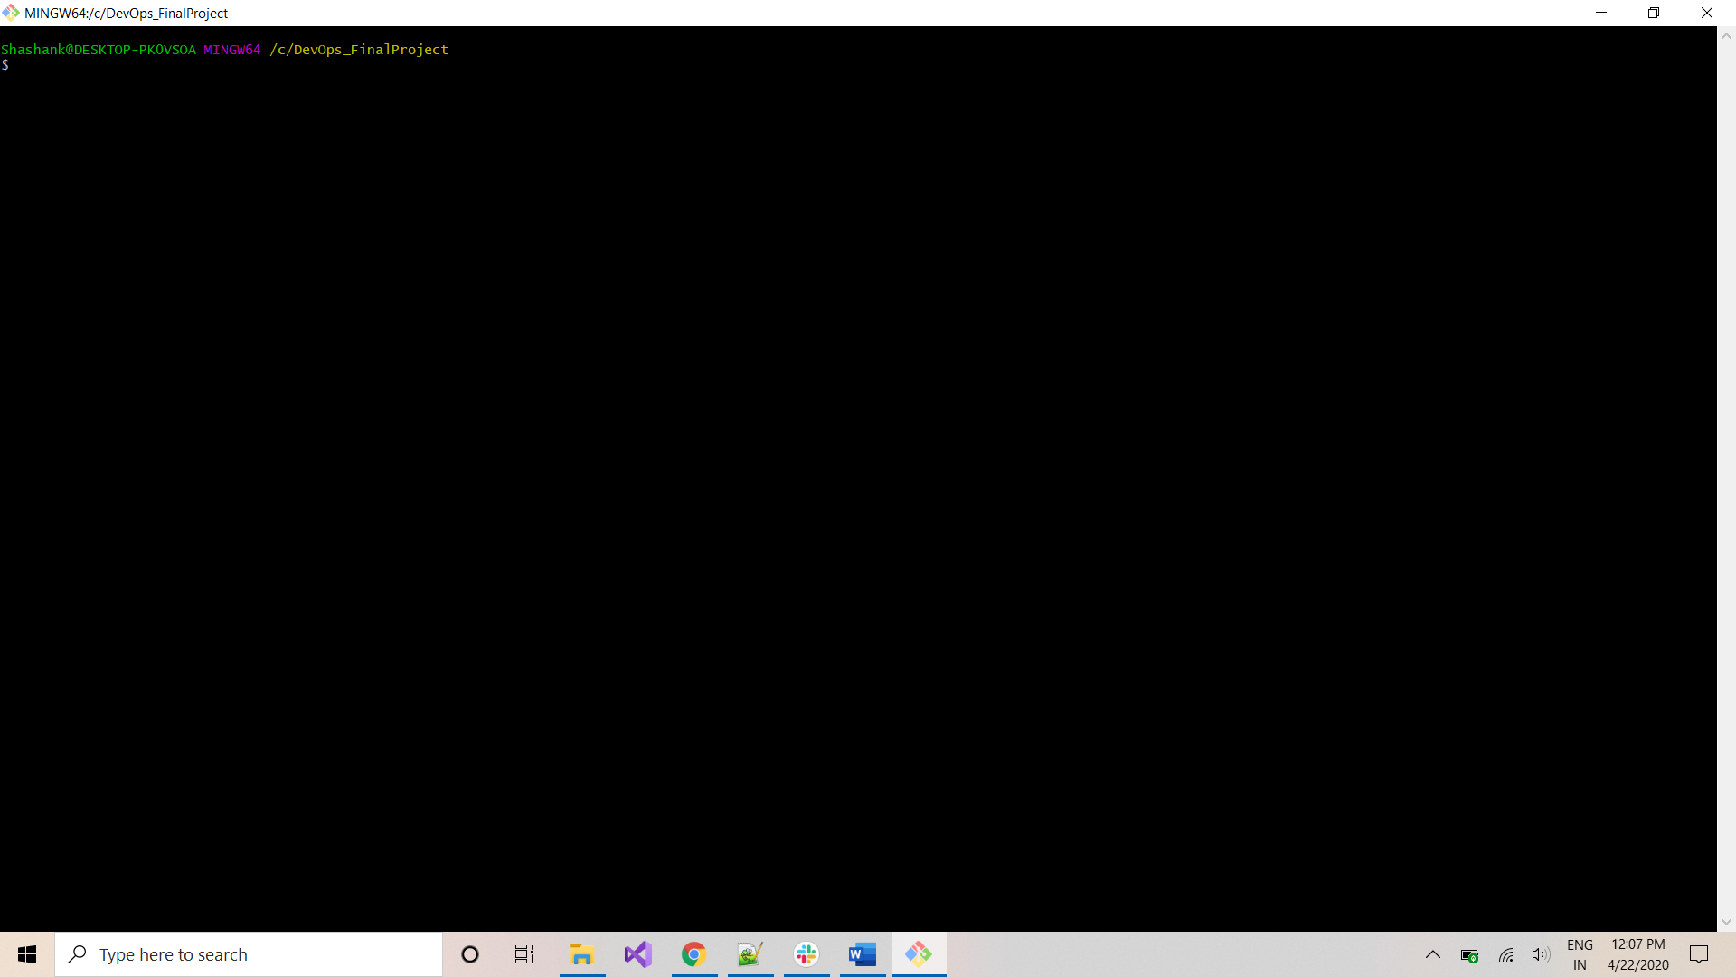

Type the command to initialize a git repo:

*git init*

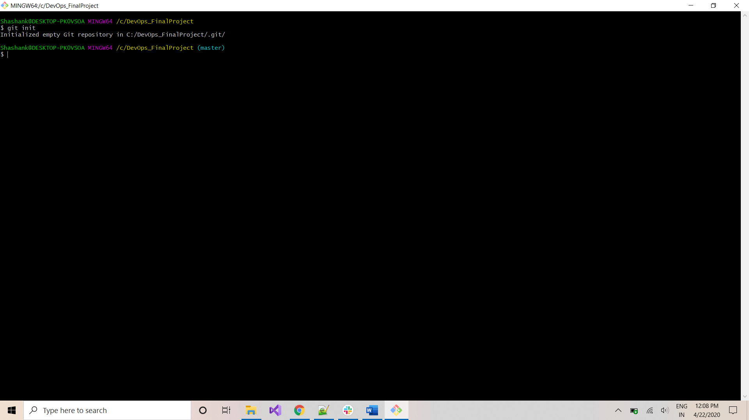

Type the command to clone the project repo:

git clone[*https://github.com/shanks2710/chatall_app.git*](https://github.com/shanks2710/chatall_app.git)

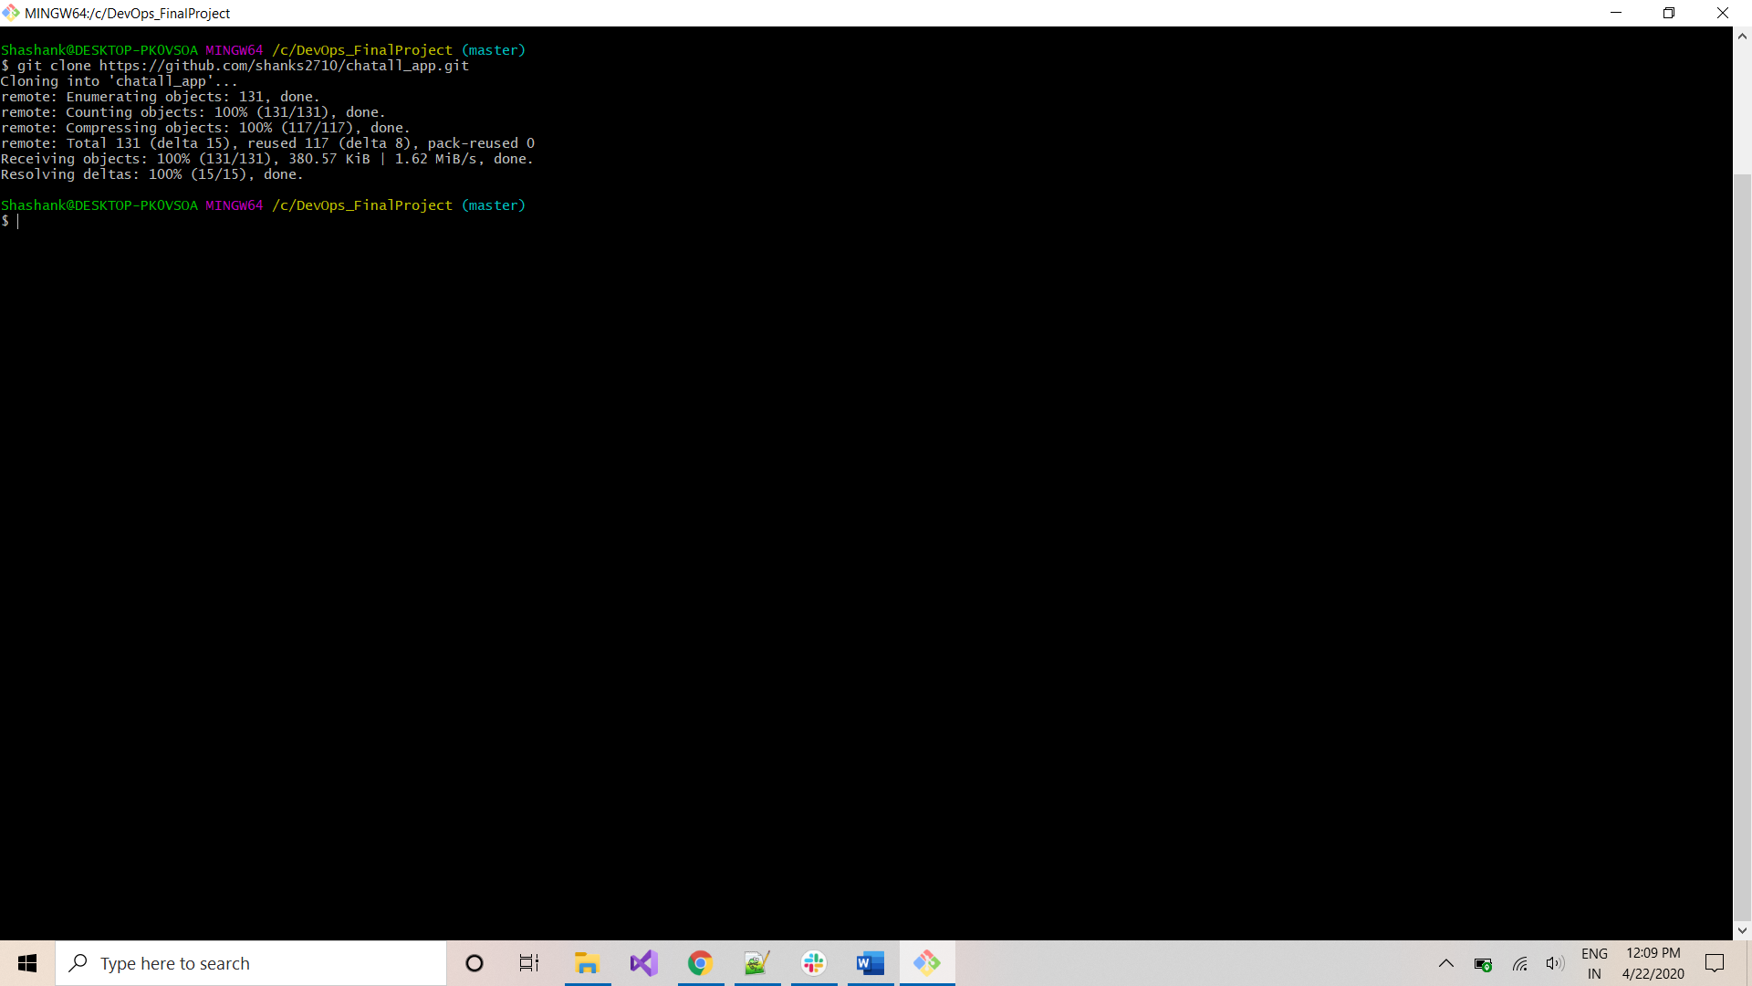

Type the below command to access the project folder and check all 3 projects have been cloned:

*cd chatall_app*

*ls -al*

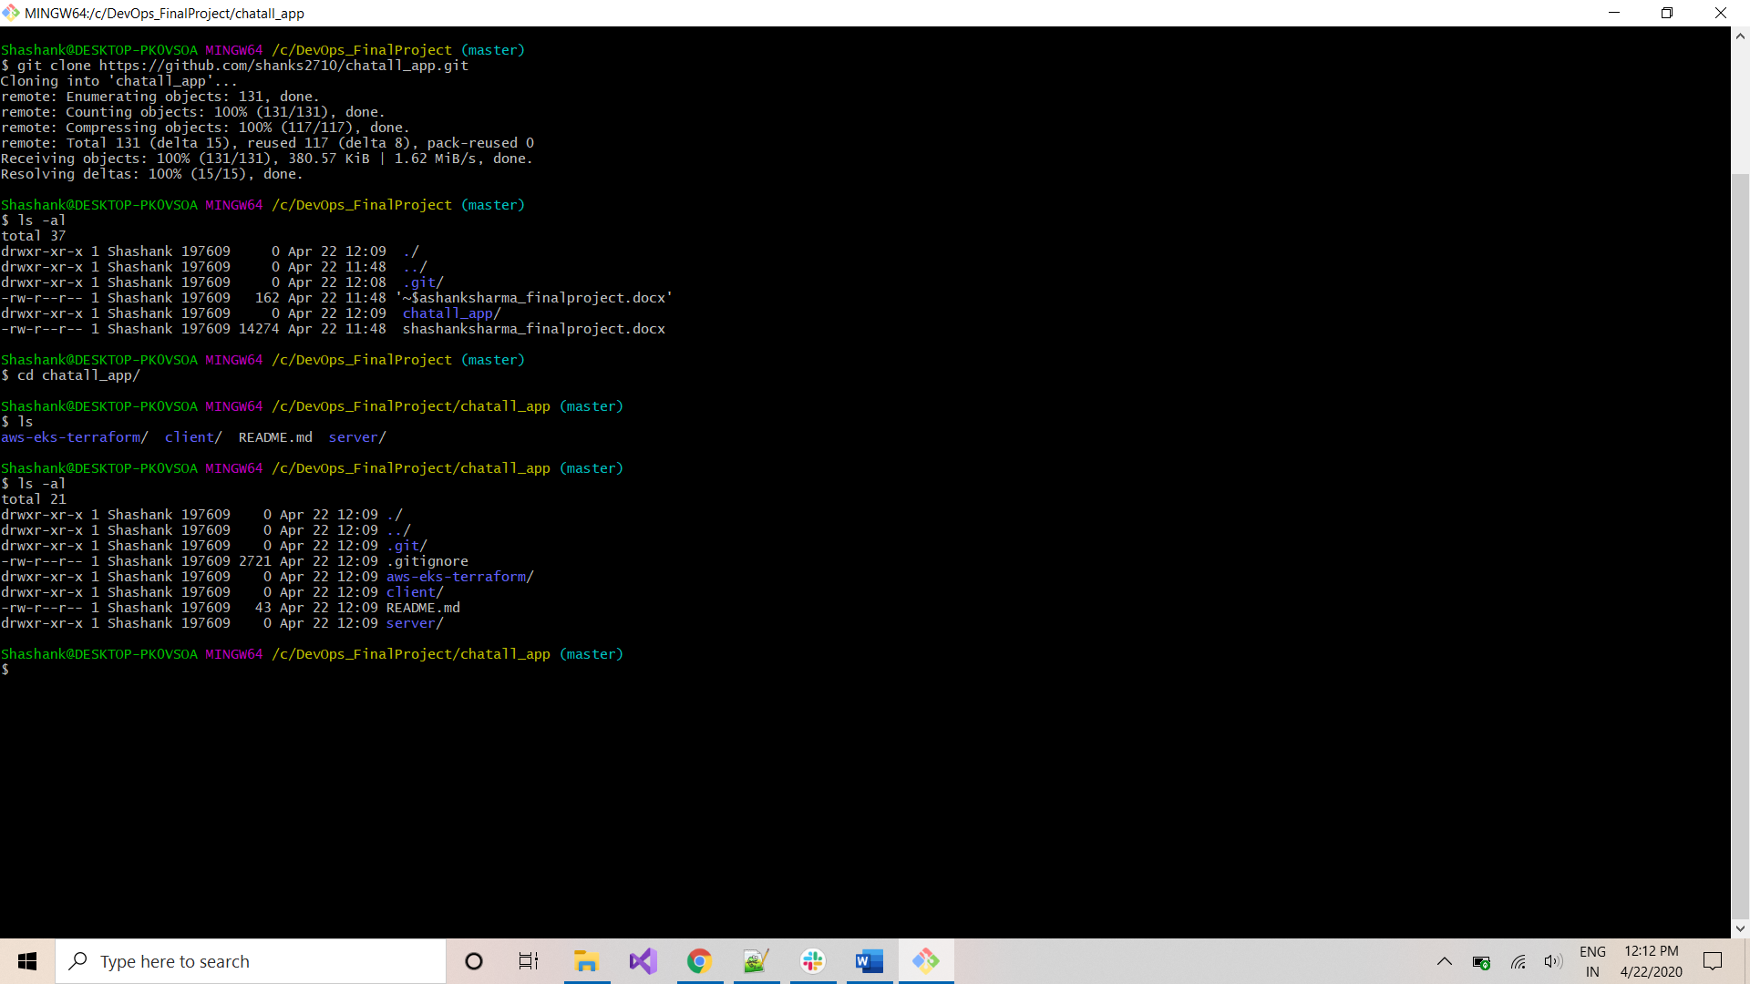

Go to this folder location using Windows Explorer and type below command in the address bar to open the Command Prompt:

*cmd*

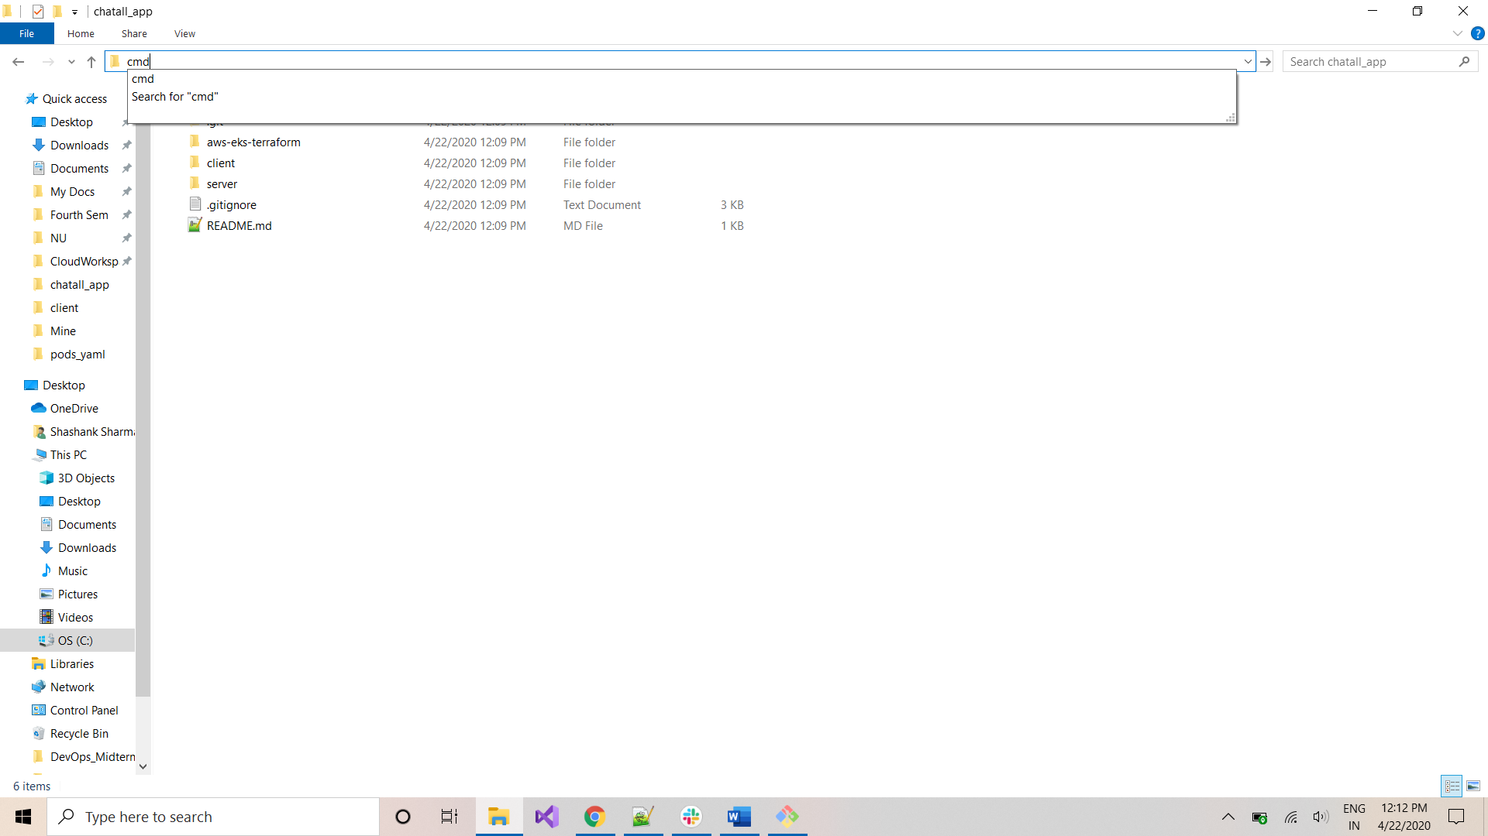

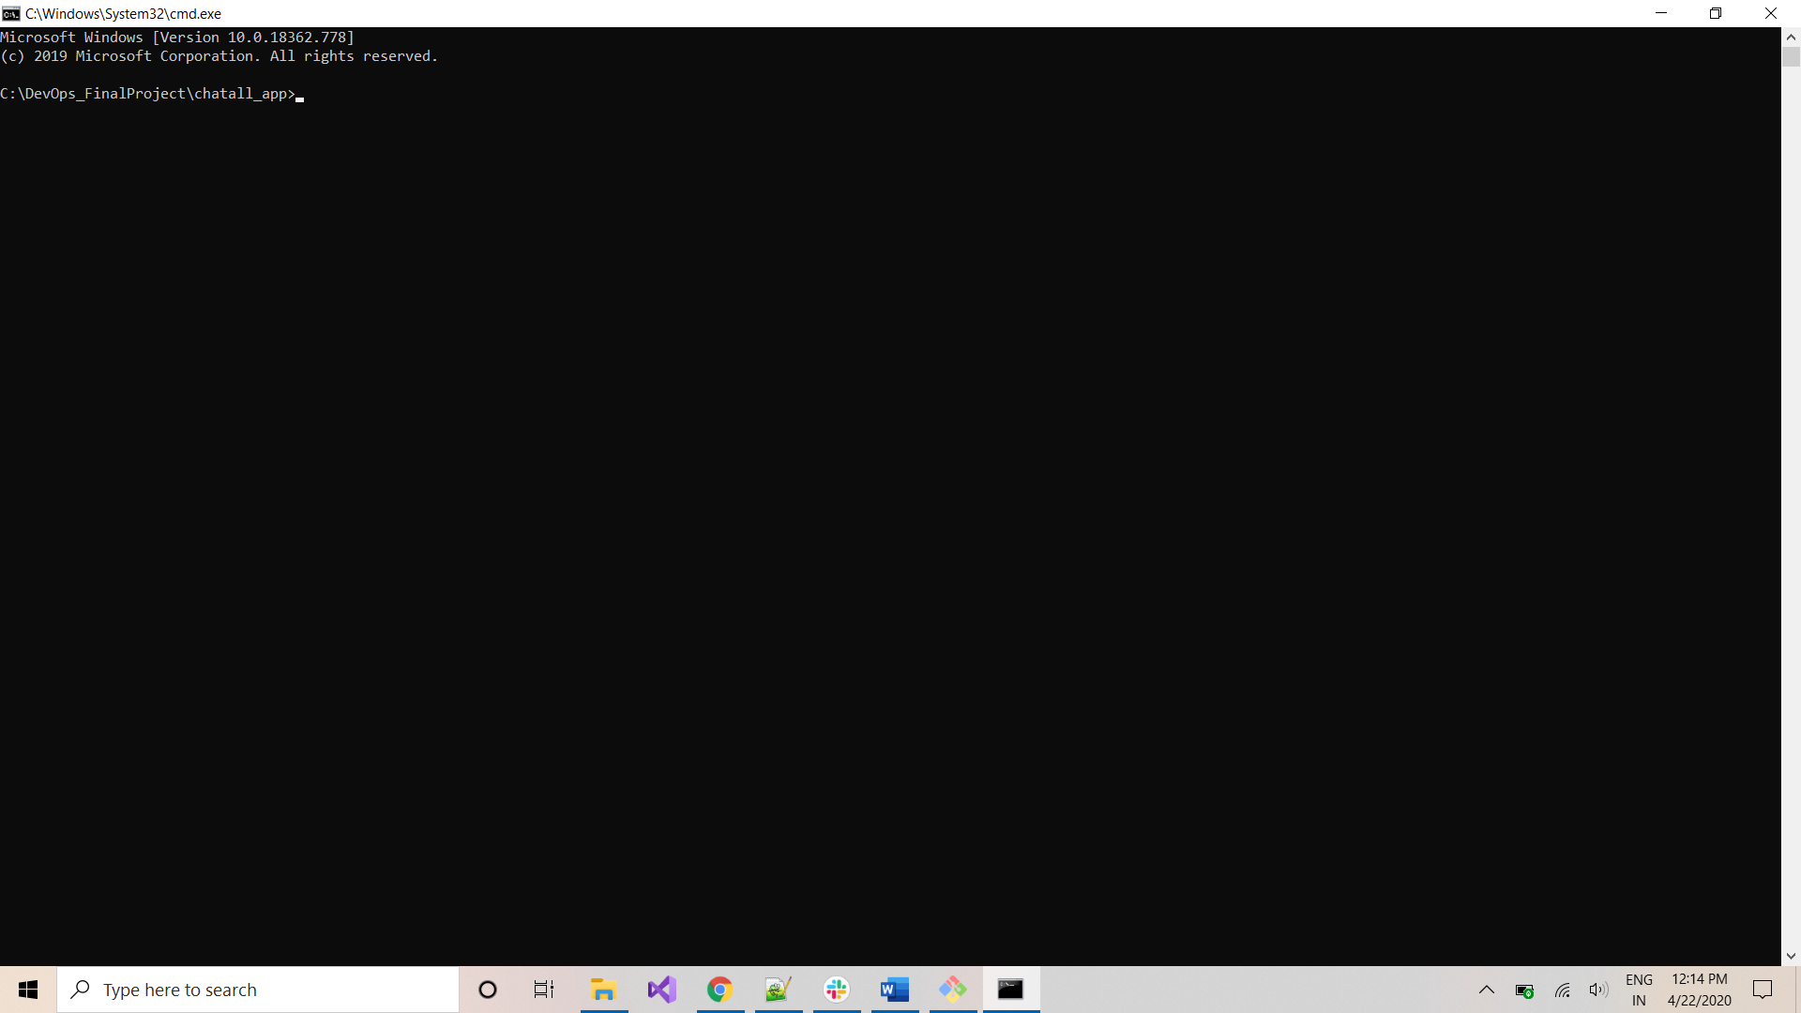

***CLUSTER-CREATION using TERRAFORM:***

*Note: The terraform script works with version 0.12.20*

Go to the aws-eks-terraform folder in the above location:

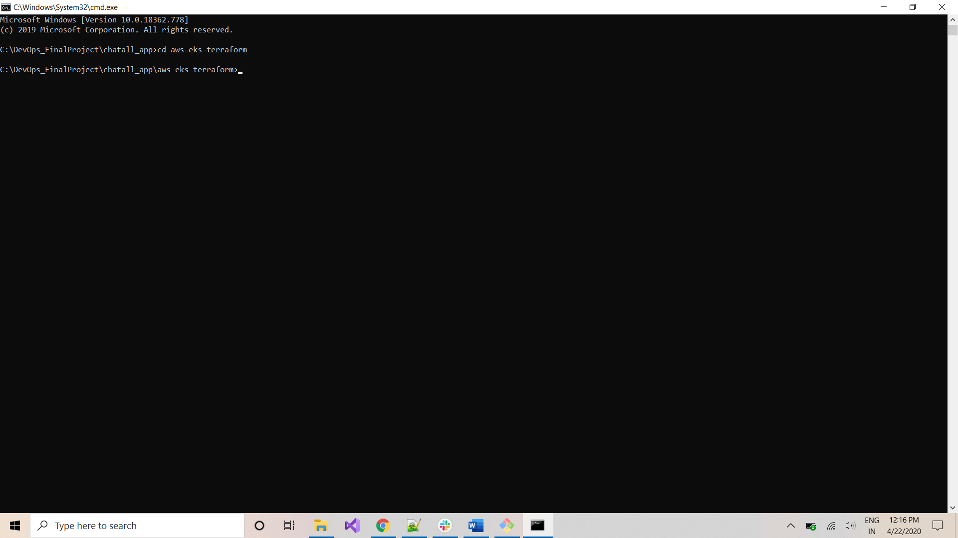

Initialize terraform with the following command:

*terraform init*

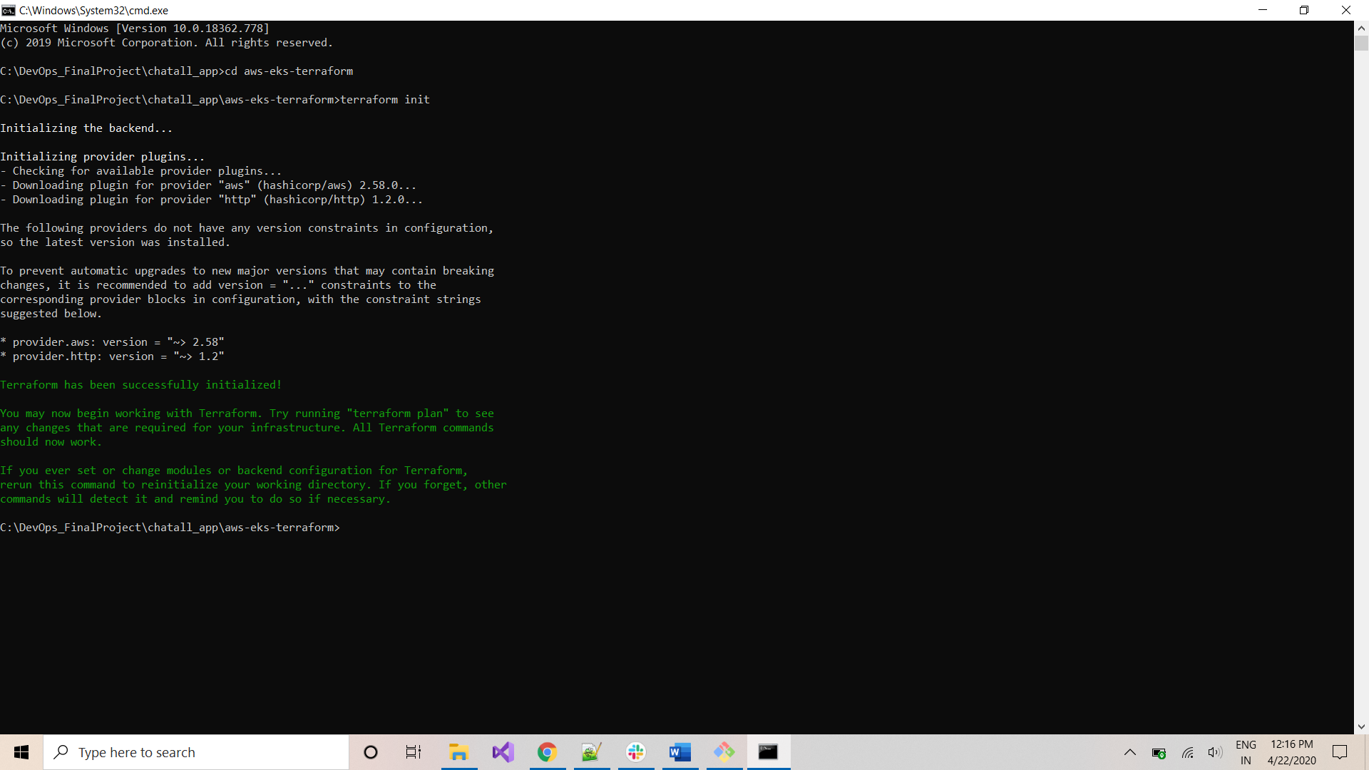

Use below command to plan terraform execution:

*terraform plan*

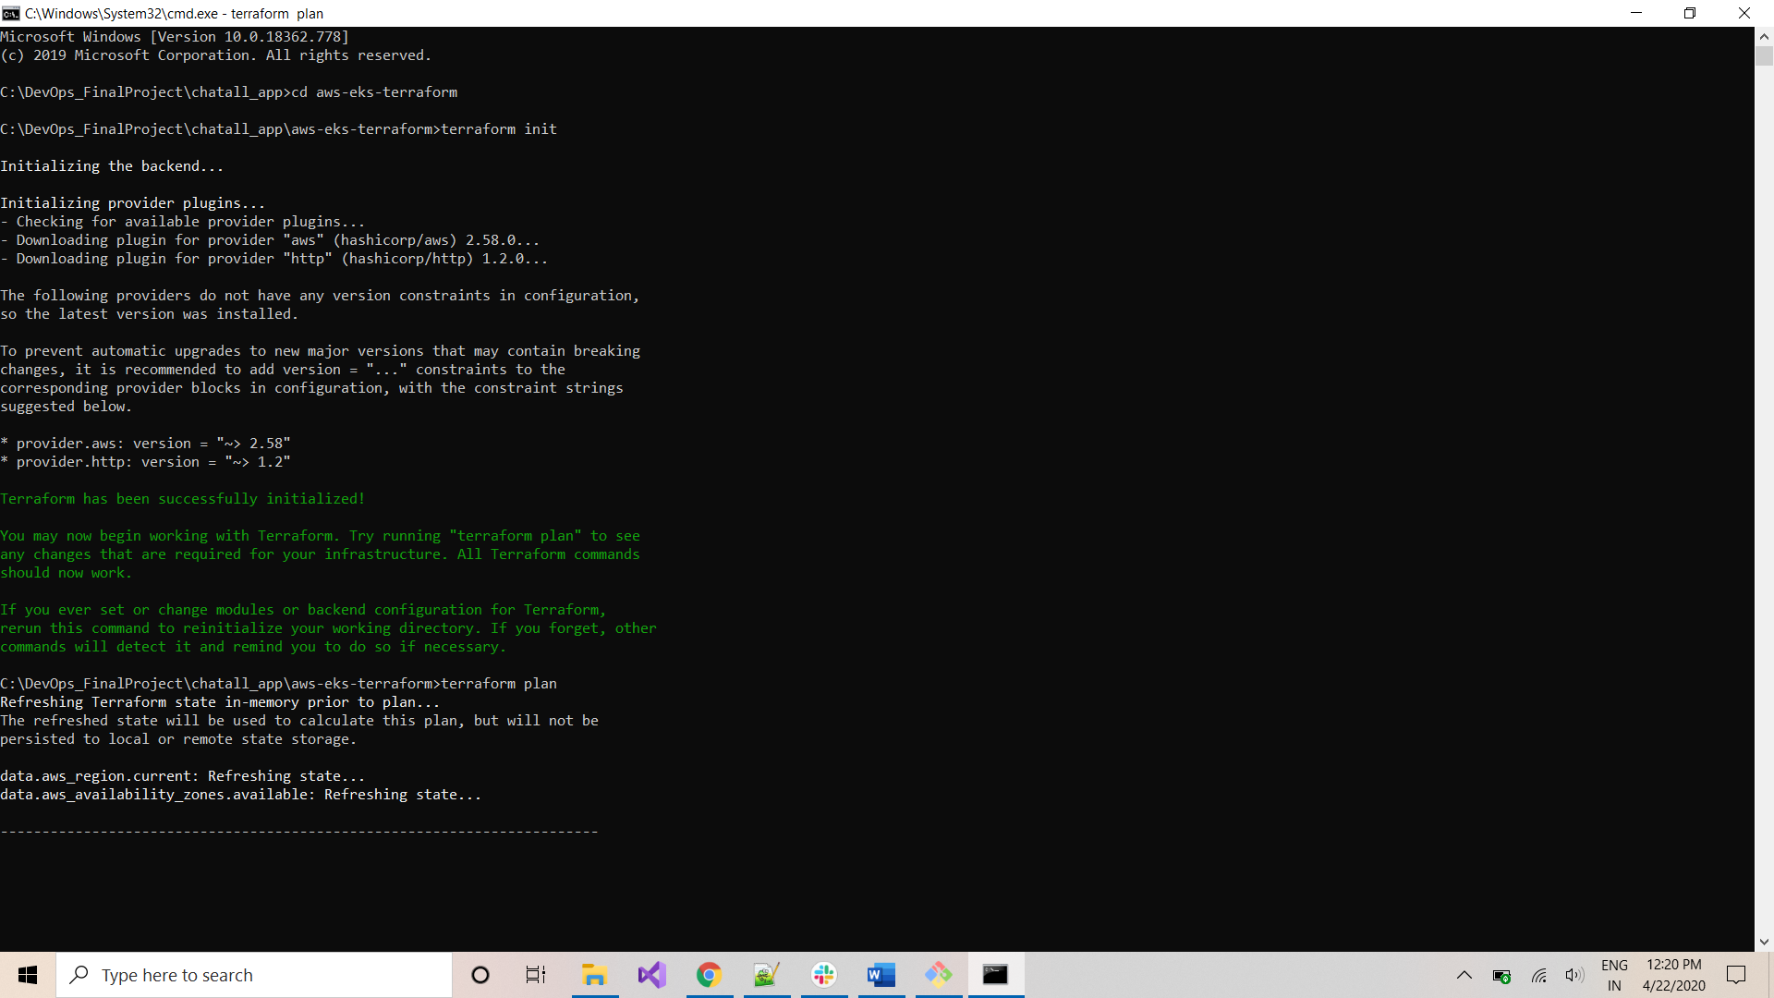

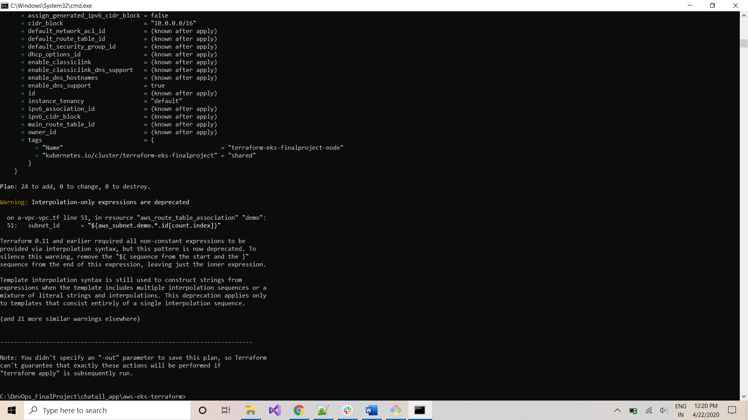

Once the execution is completed, type the below command to execute terraform script:

*terraform apply*

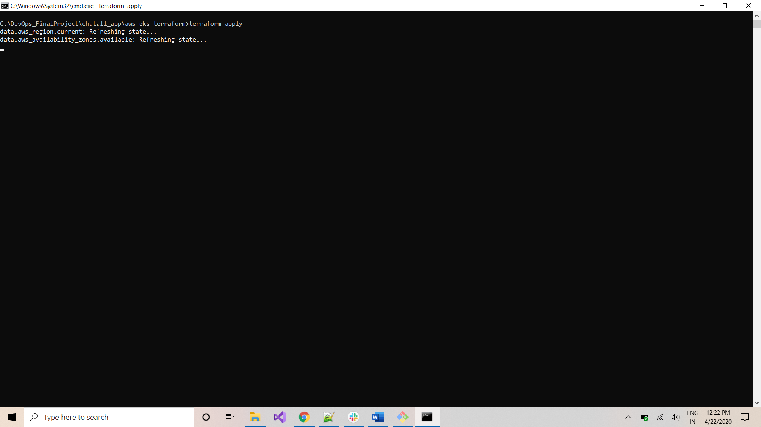

Type ‘*yes’* and click *Enter* to start execution:

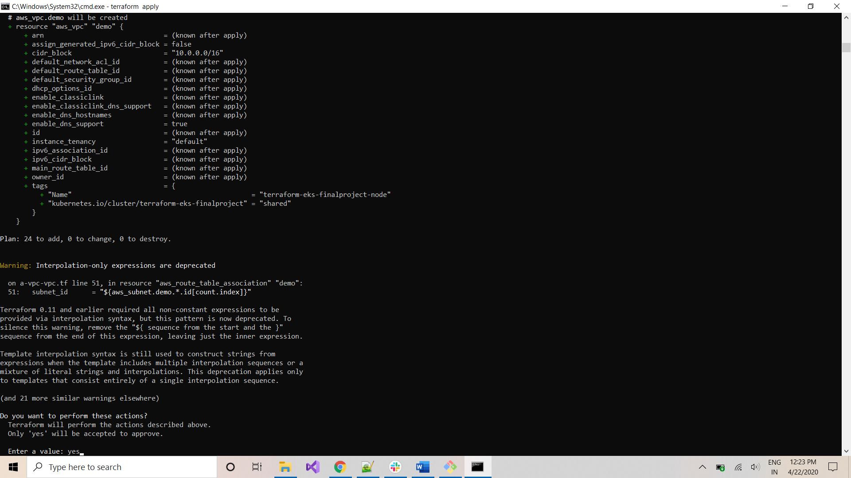

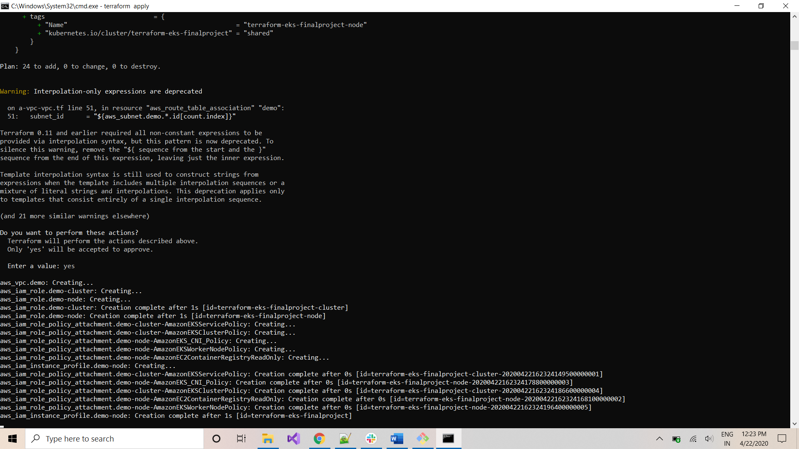

Follow progress through the screen. It takes around 15mins for the script to execute:

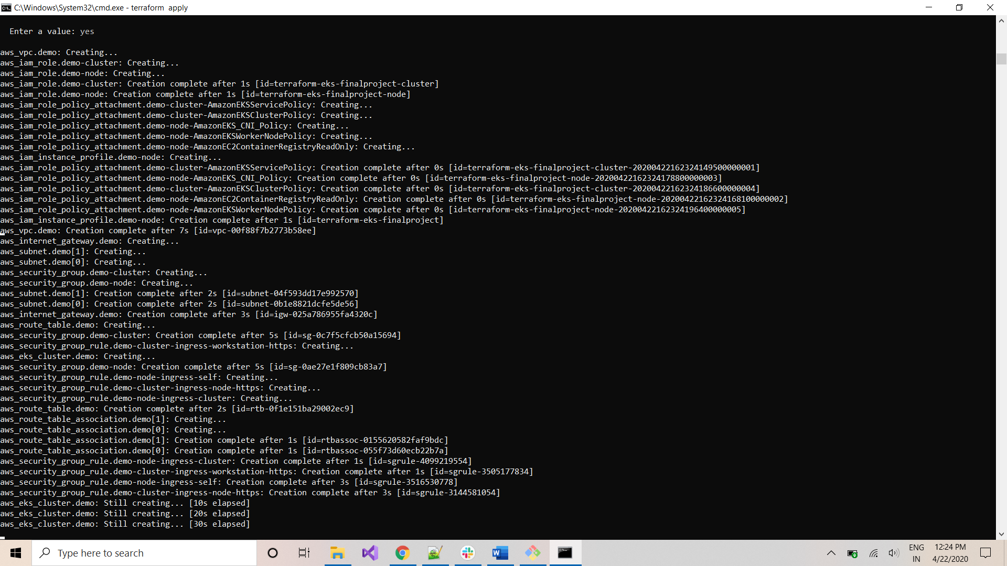

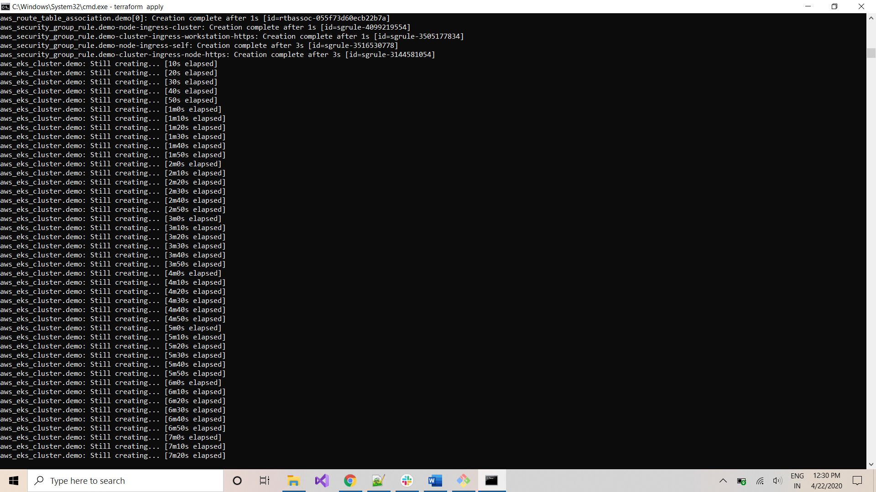

Open AWS management console: [*https://aws.amazon.com/console/*](https://aws.amazon.com/console/) and navigate to EKS in ‘*us-west-2*’ region to see progress of deployment:

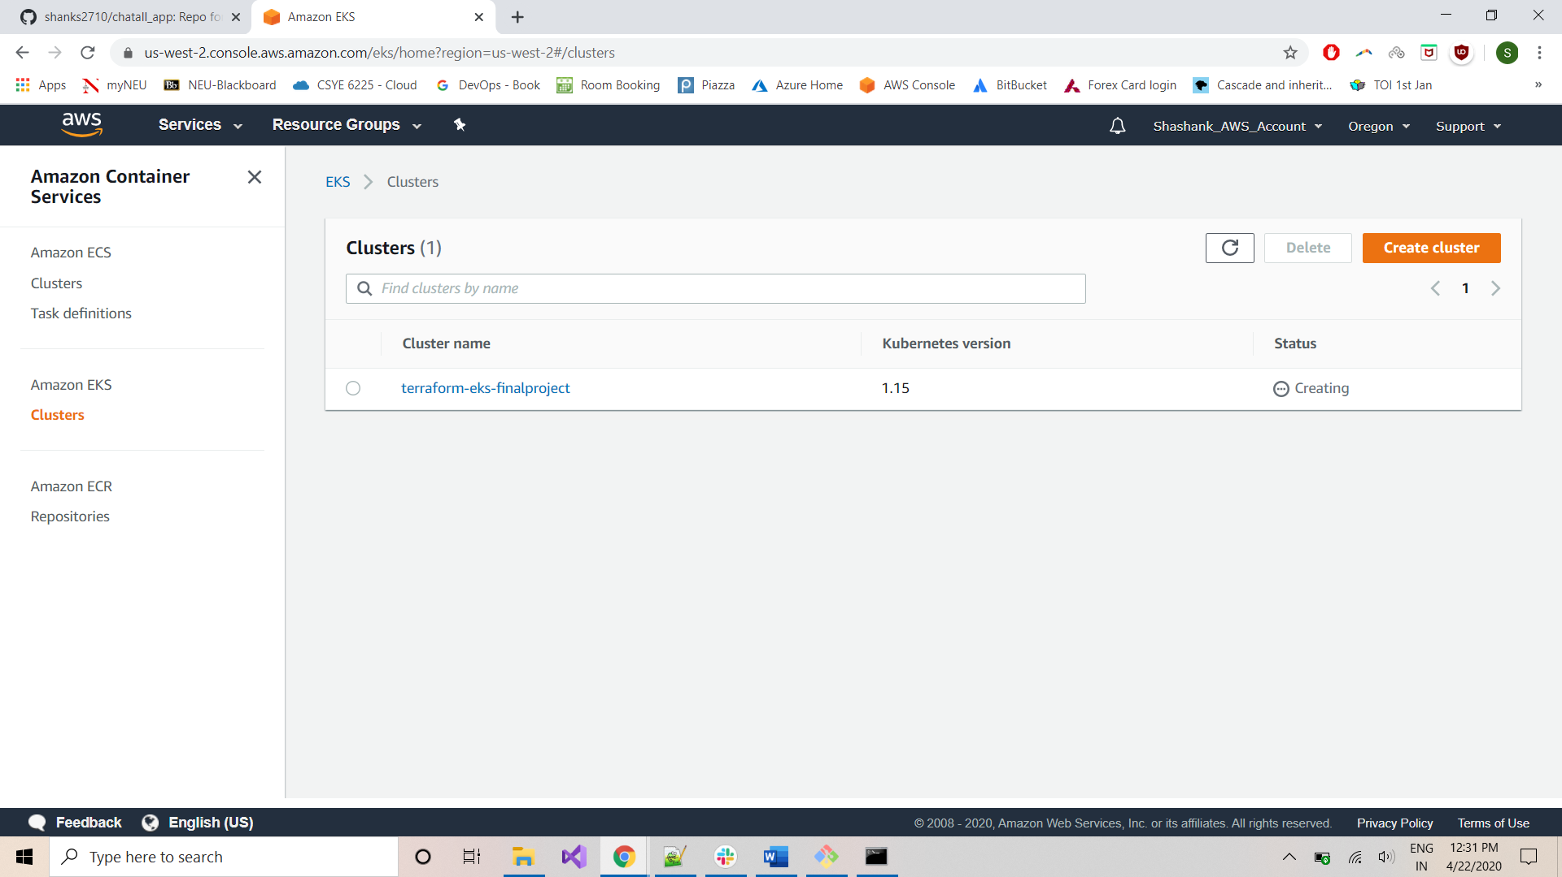

When script completes, terraform outputs config-auth map and kube-config:

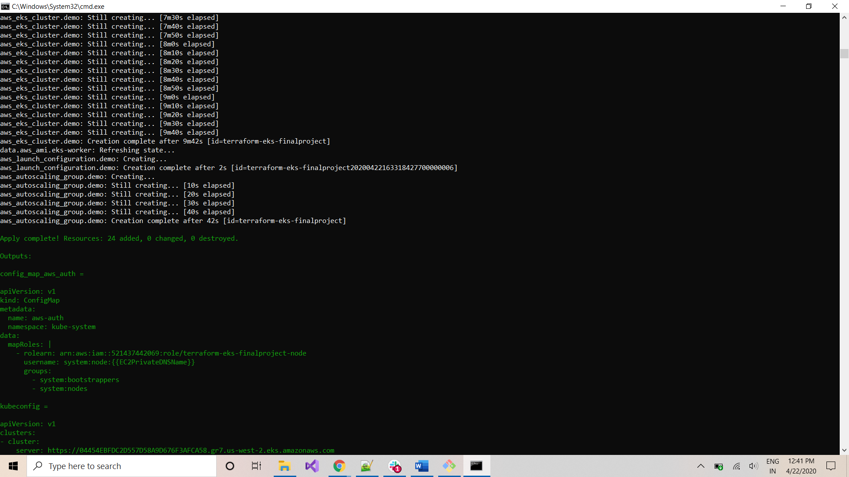

*kube-config is omitted due to security reasons

Same can be verified from AWS console:

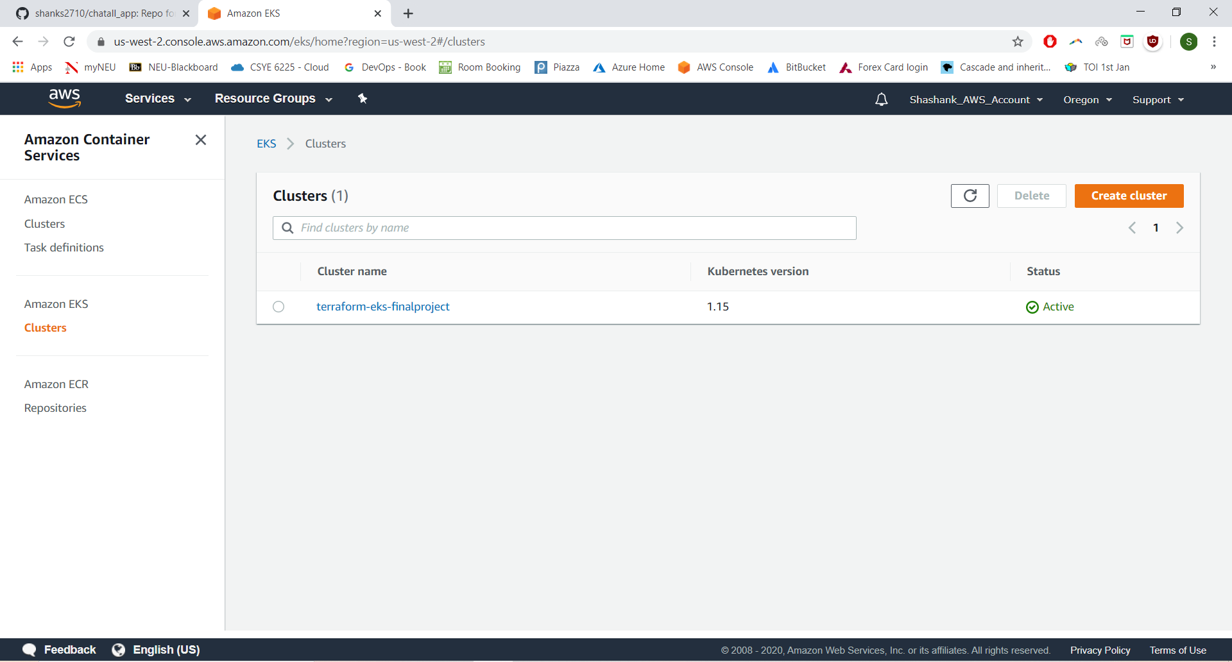

Navigate to below folder to access the *config* file for *kubectl: C:\Users\<your-windows-username> \.kube*

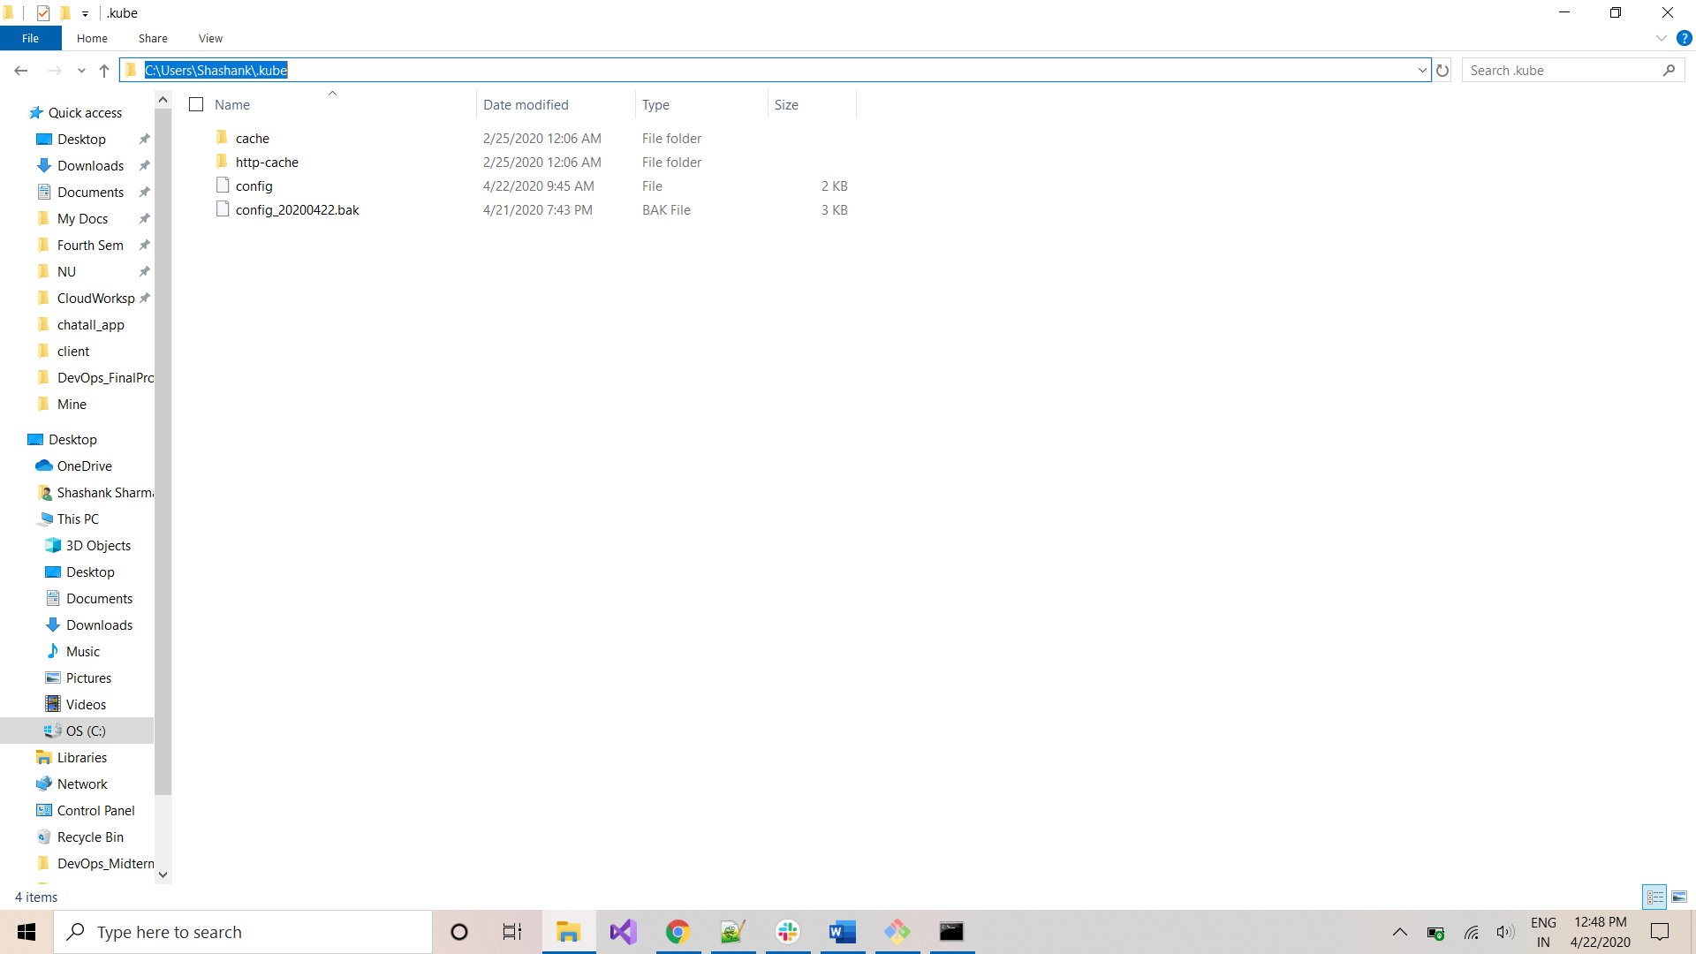

Create a backup of the config file:

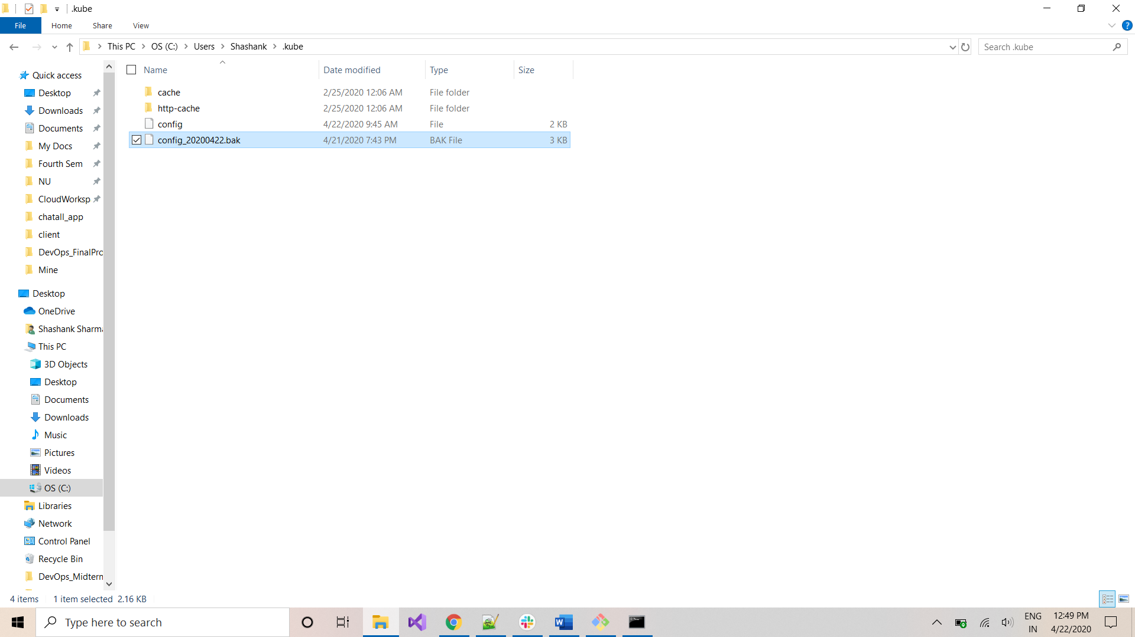

Navigate back to *Command-Prompt.* Execute the below command to copy the kubeconfig to your local kubectl-config:

*terraform output kubeconfig > c:/Users/Shashank/.kube/config*

*replace Shashank with your windows username in above command

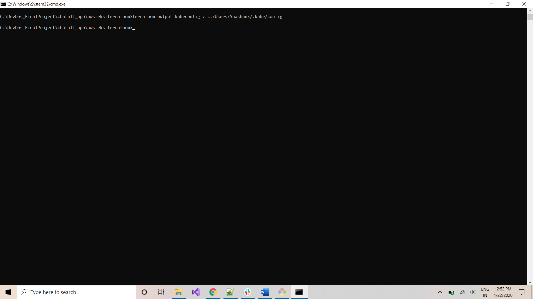

Copy and rename the config-map for this execution using the below command:

*terraform output config_map_aws_auth > ./config-map-aws-auth.yml*

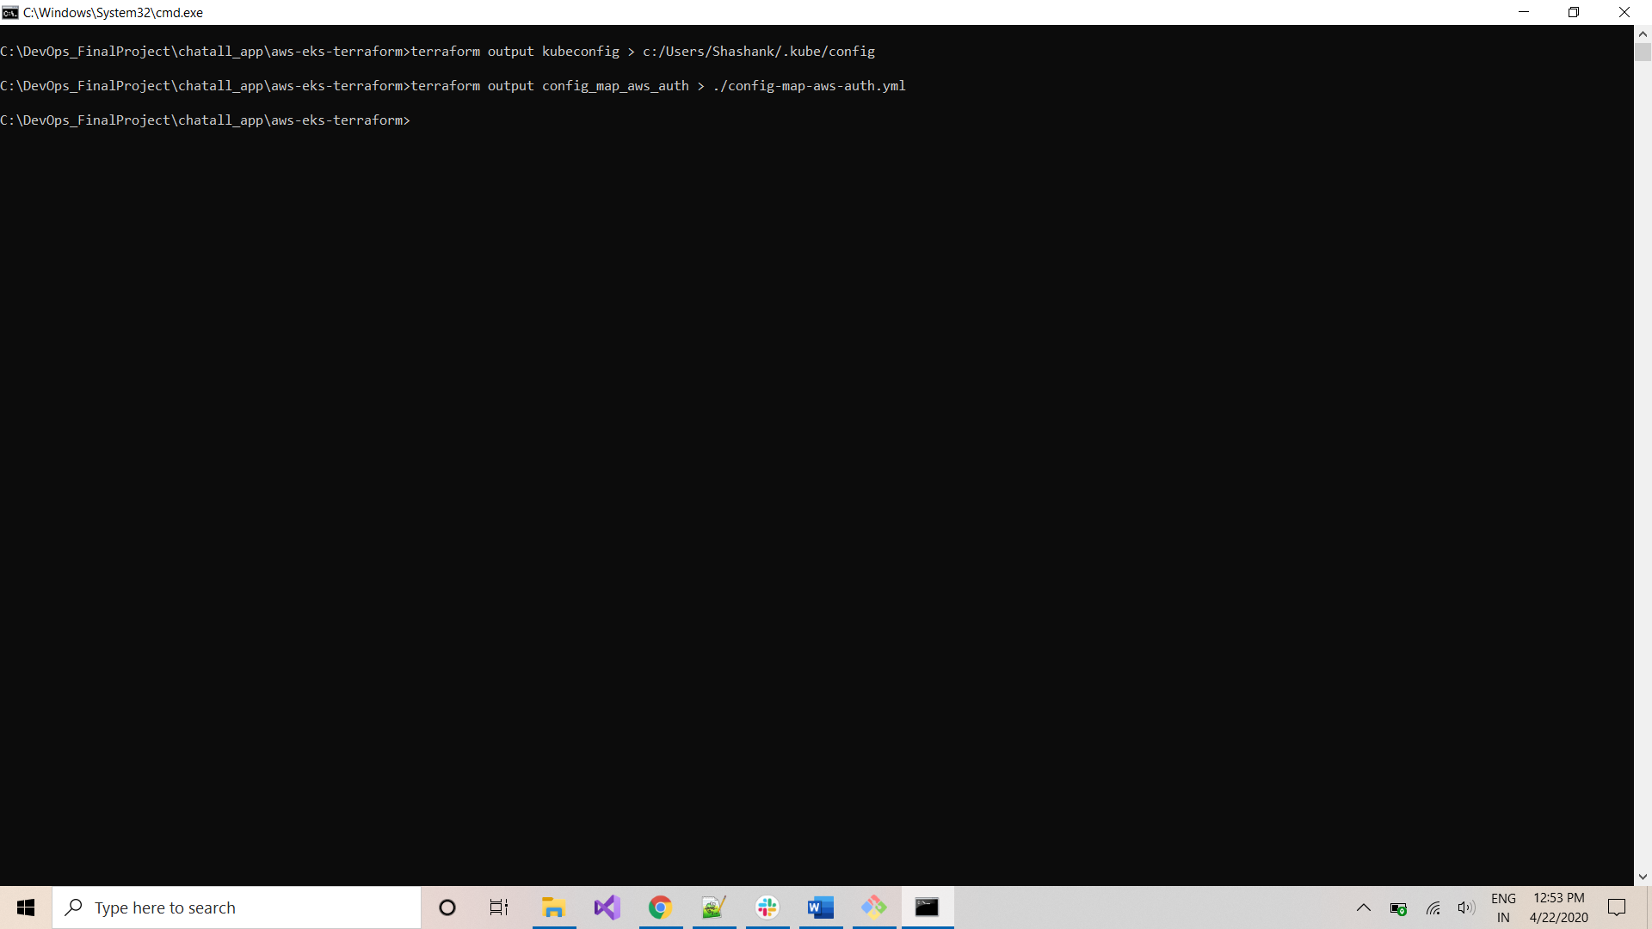

Using *kubectl* apply the config-map for the cluster:

*kubectl apply -f ./config-map-aws-auth.yml*

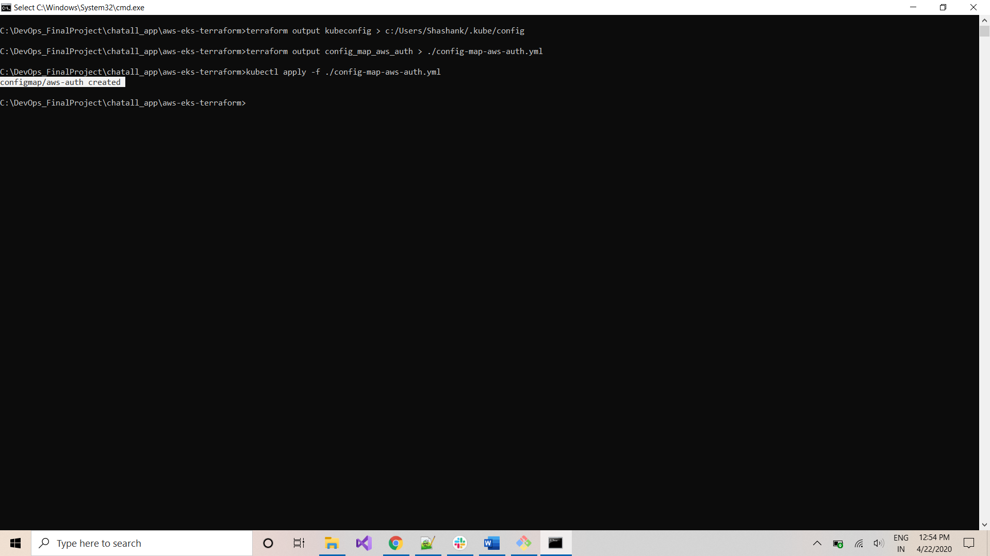

The EKS cluster is successfully setup in AWS and you can control the same using your laptop!

***DOCKERIZING Back-end Application***

Navigate to the folder where you checked-out the project:

*C:\DevOps_FinalProject\chatall_app*

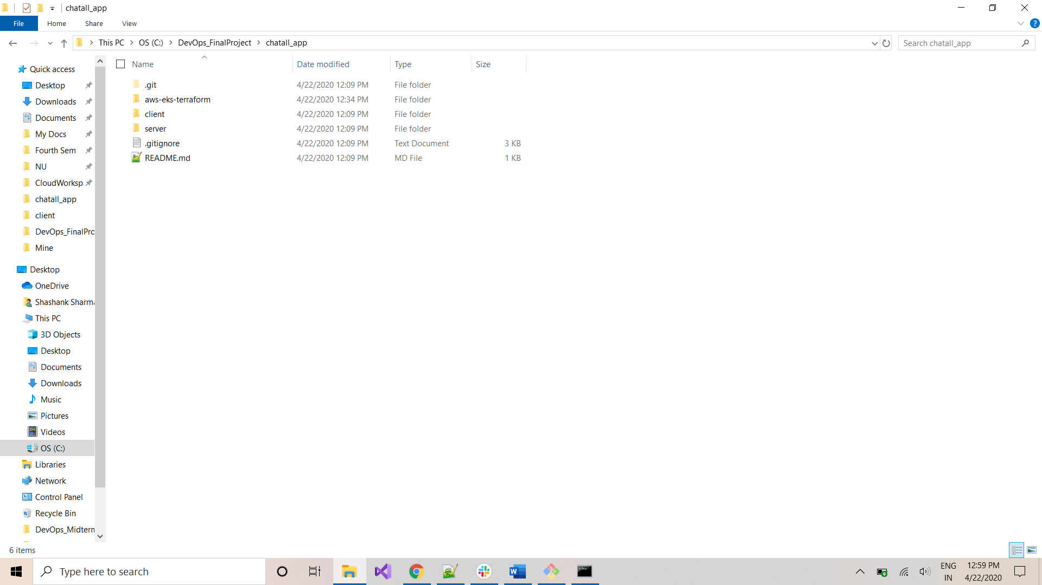

Open git-bash on this location:

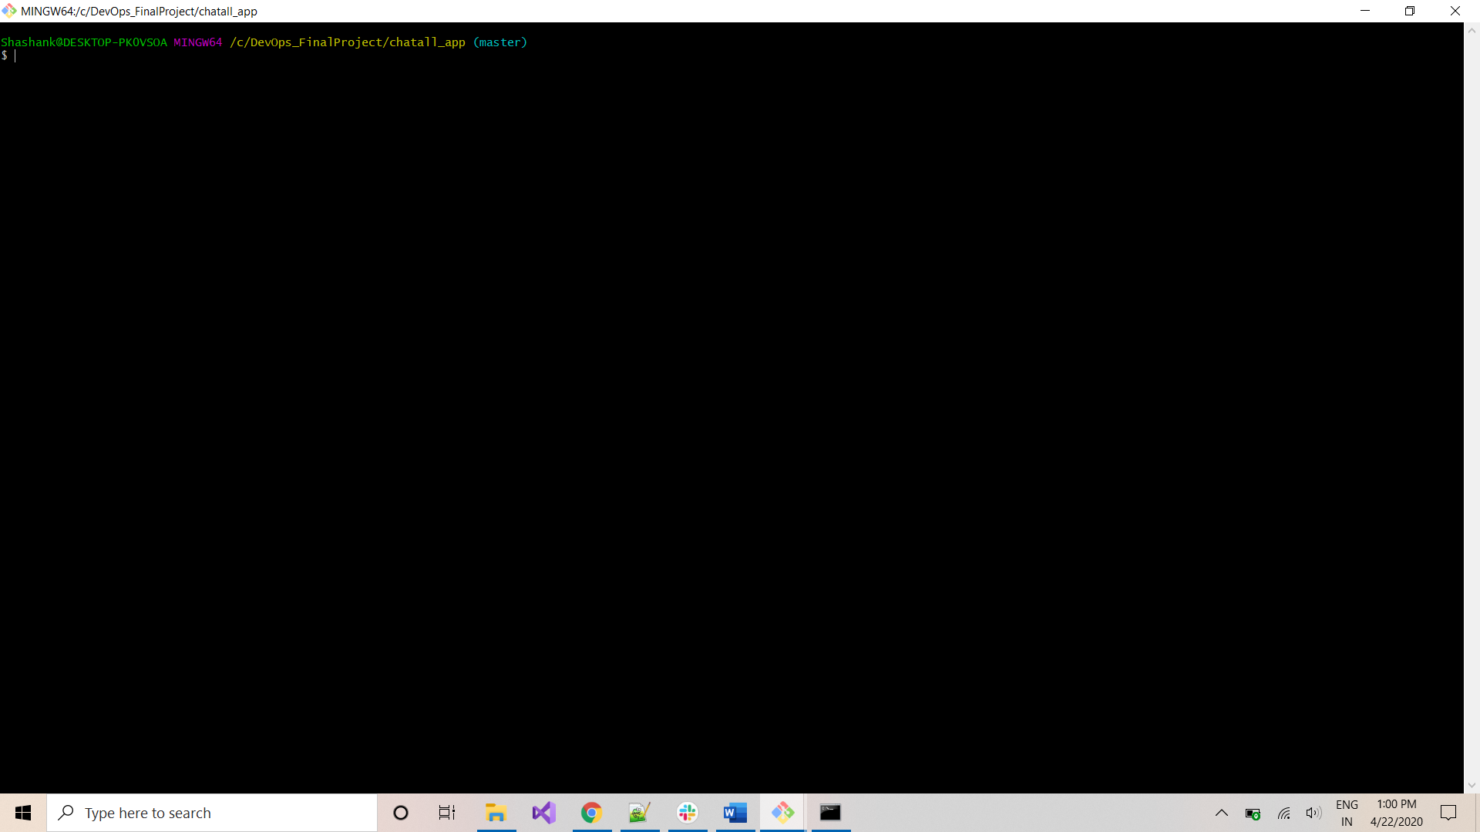

Navigate to *server* folder using below command:

*cd server*

*ls -al*

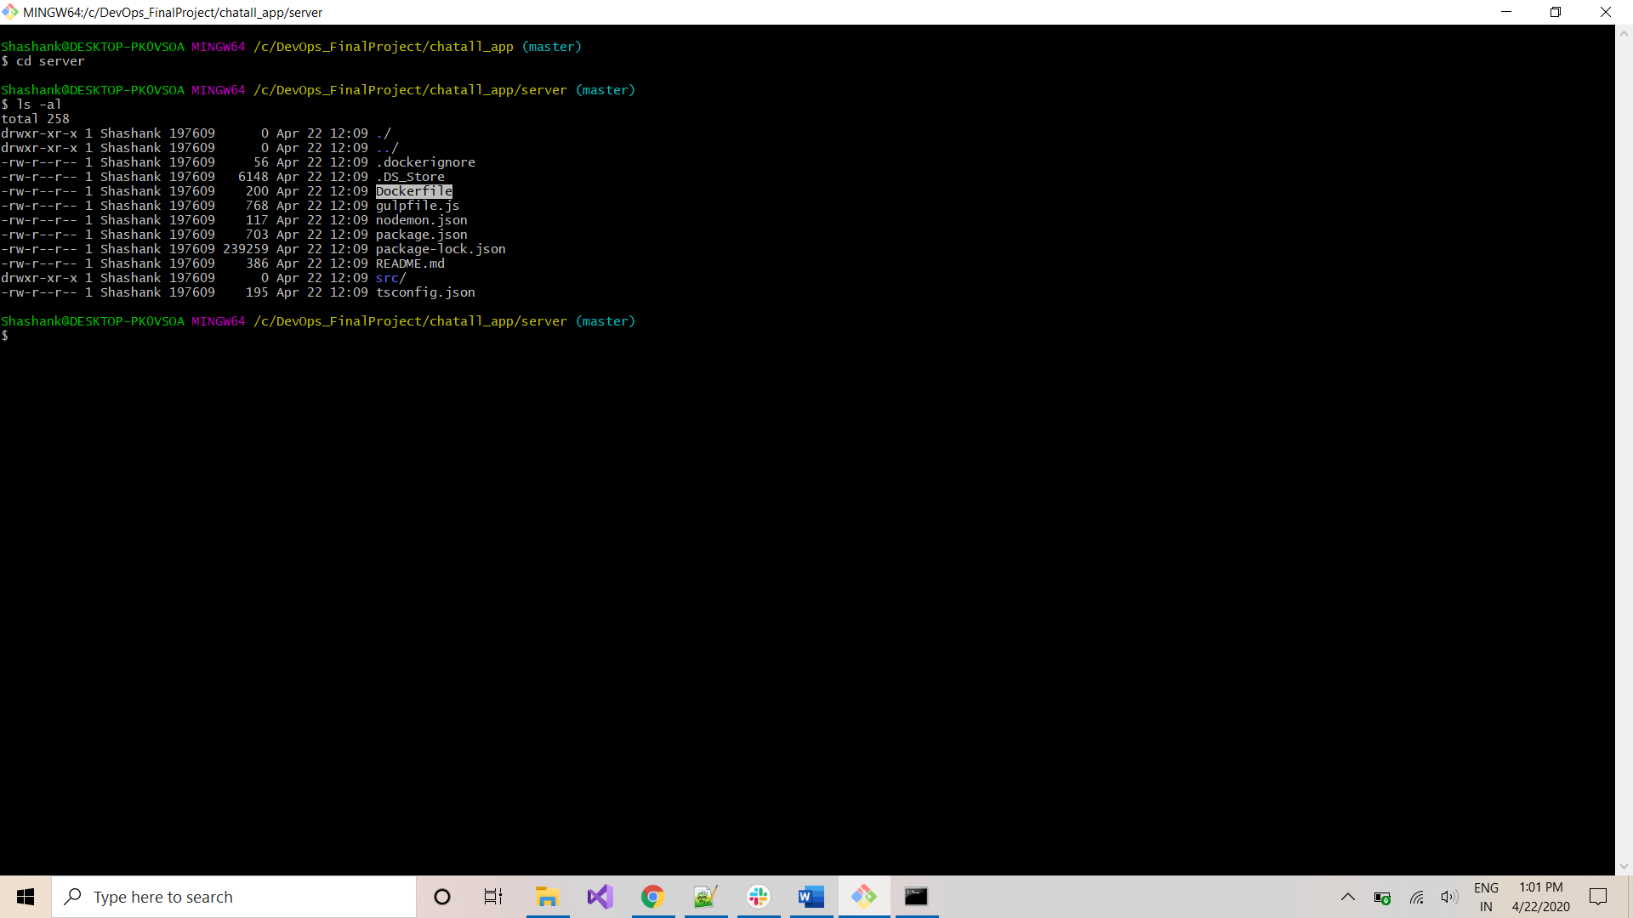

*You will find the Dockerfile for this project at this location. Start Docker-Toolbox on your machine and login to dockerhub:*

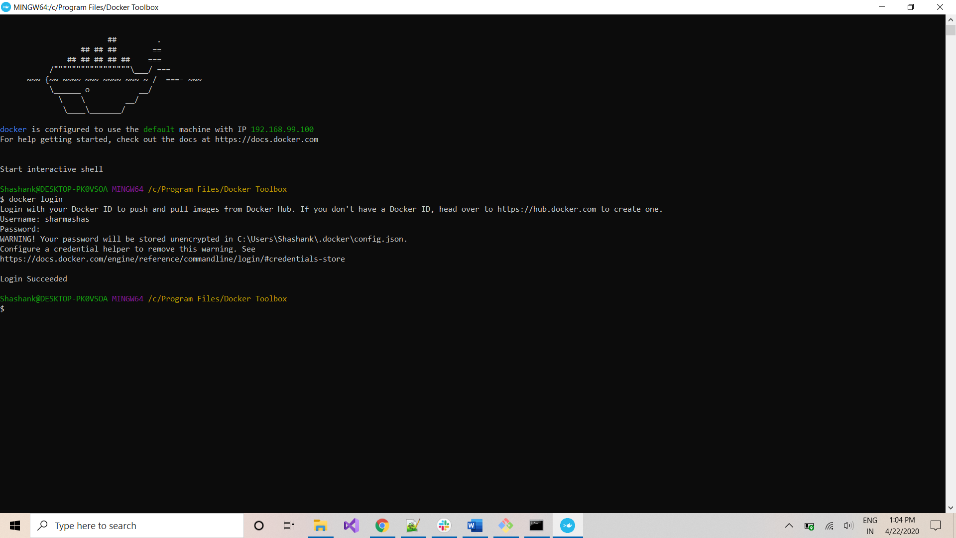

Navigate back to git-bash window and execute the below commands to create an image and publish it to DockerHub:

*\*replace sharmshas with your Dockerhub-ID in below statements:*

*docker build -t sharmashas/chatserverapp .*

*docker push sharmashas/chatserverapp*

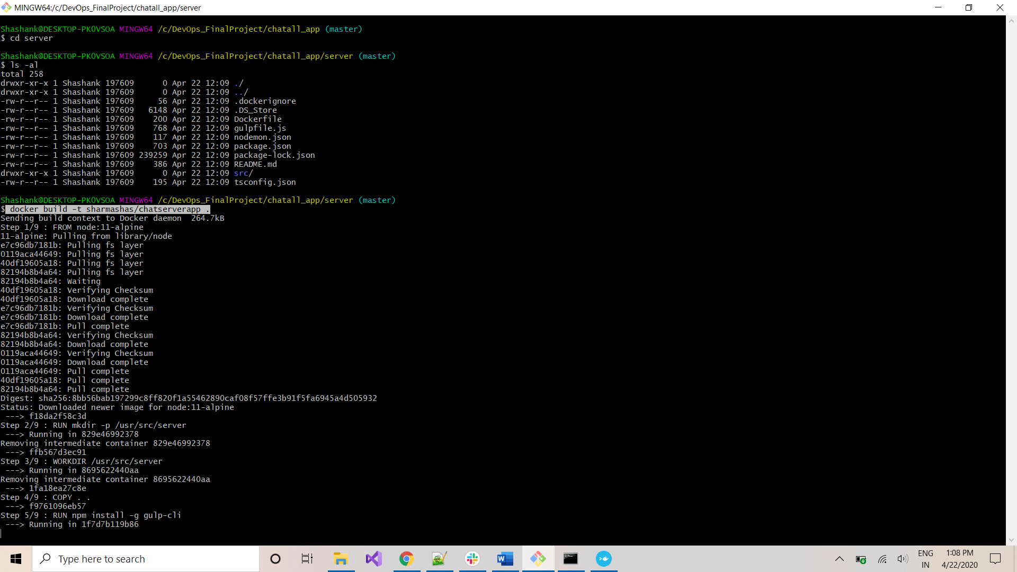

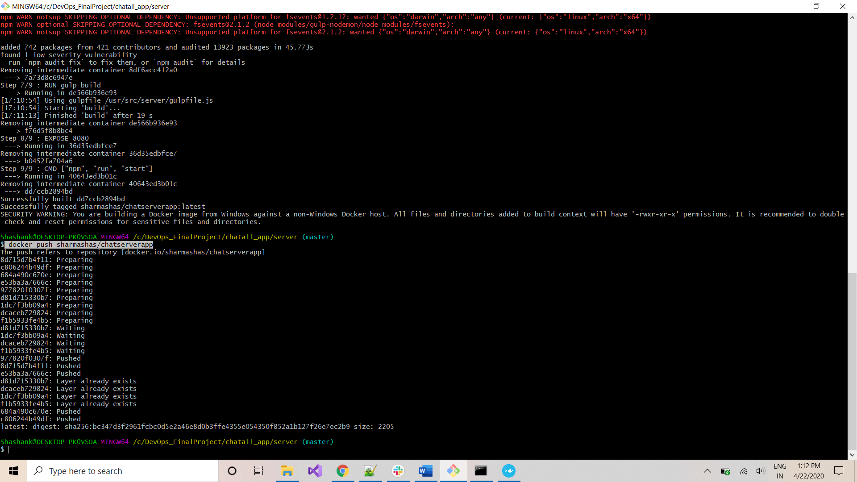

***DEPLOY Back-end Application on CLUSTER***

Once the image has been published to your DockerHub account, navigate to the *Command-Prompt.* Execute below command to navigate to folder with *deployment* and *service* yamls:

*cd pods_yaml*

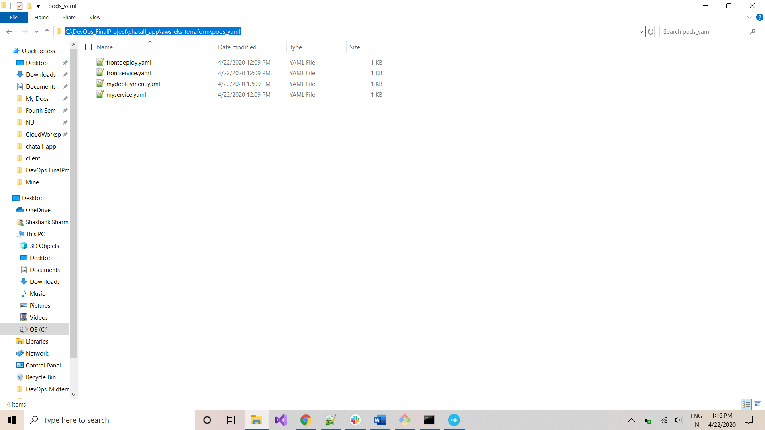

Navigate to folder: C:\DevOps_FinalProject\chatall_app\aws-eks-terraform\pods_yaml

& Open mydeploy.yaml in a text-editor like Notepad++ and specify the dockerhub image at below location:

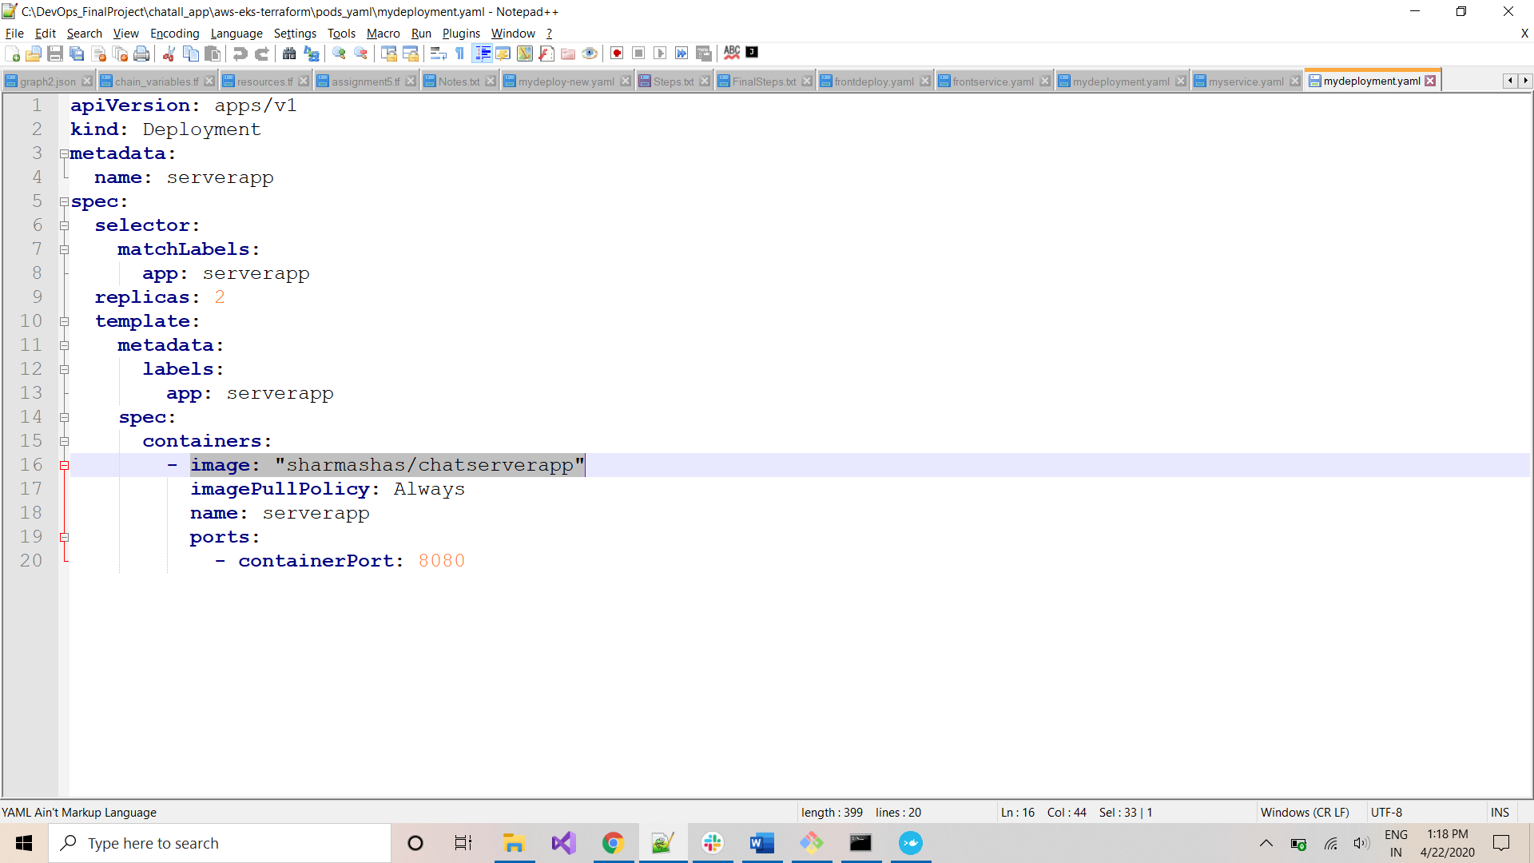

Navigate back to command-prompt and execute the below command to deploy pods for backend-application:

*kubectl apply -f mydeployment.yaml*

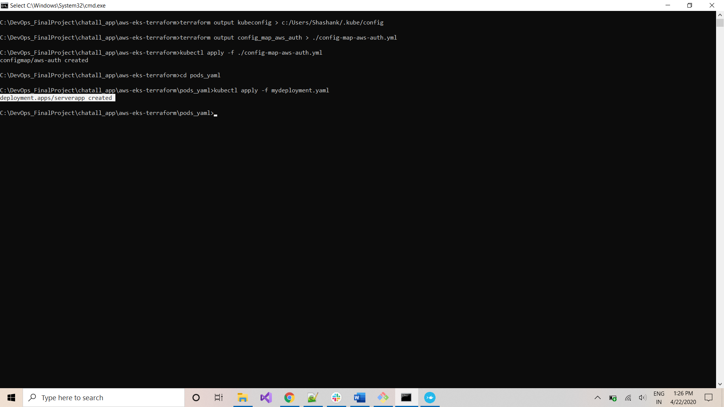

Execute the below command to create a service for this deployment:

*kubectl create -f myservice.yaml*

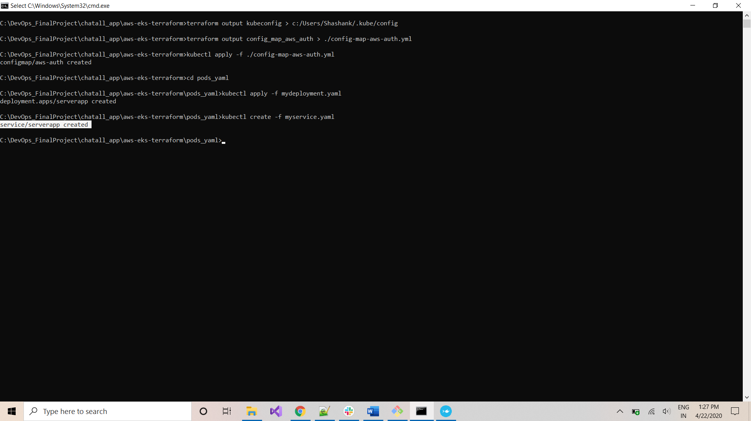

Execute the below command to check if service was created:

*kubectl get svc*

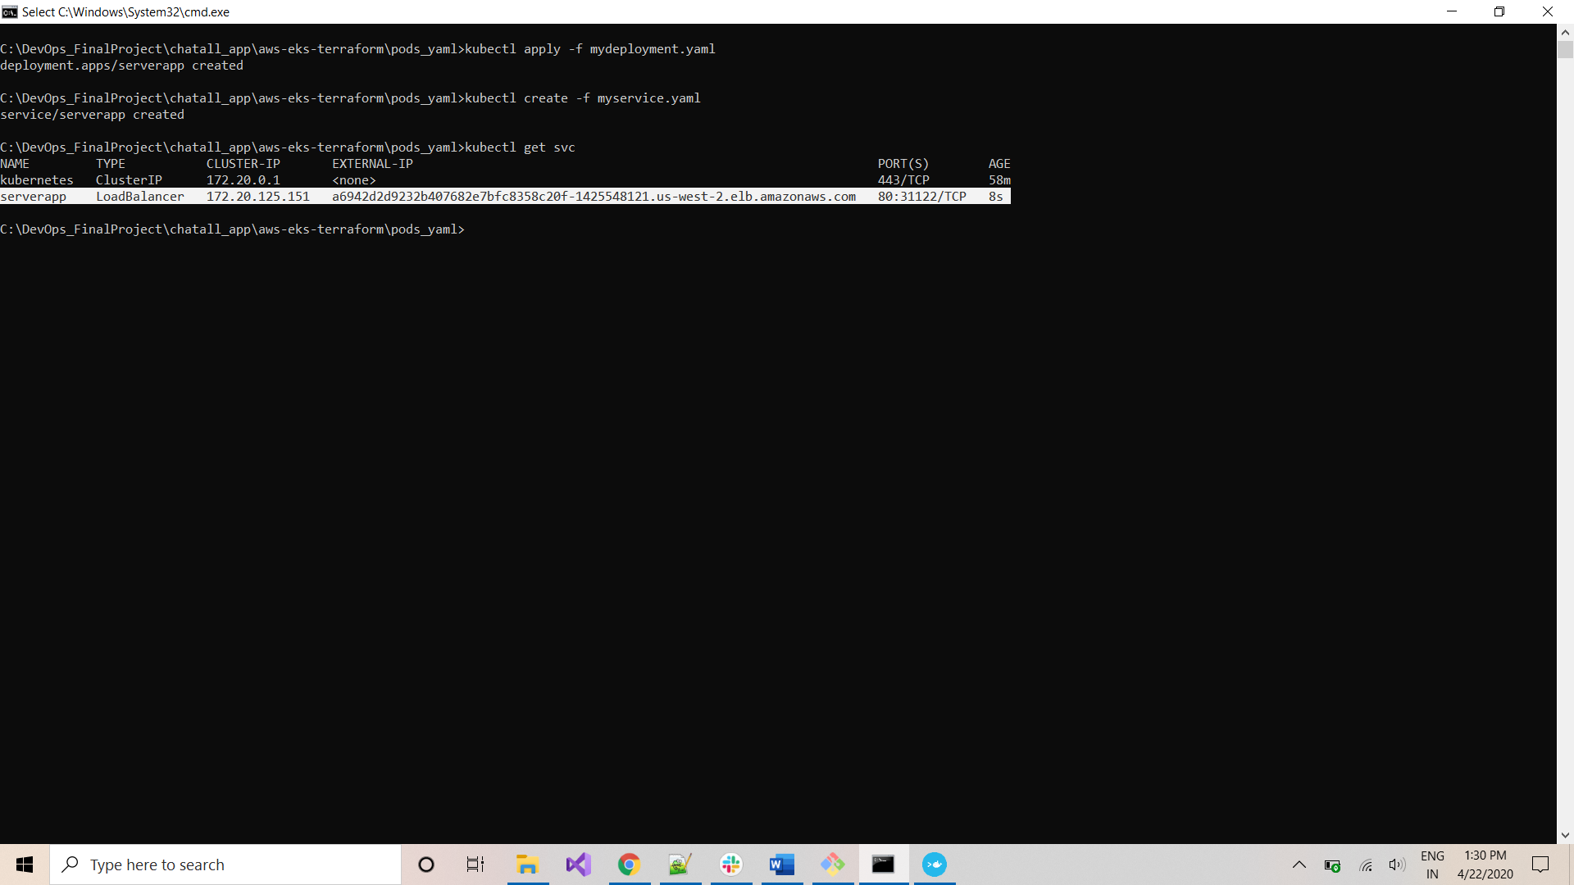

Capture the *External-IP* for this service. We will use the same to access the backend from frontend.

*External-IP: a6942d2d9232b407682e7bfc8358c20f-1425548121.us-west-2.elb.amazonaws.com*

***LINK Front-end to Back-end***

Navigate to the below location in ‘*client’* folder:

*C:\DevOps_FinalProject\chatall_app\client\src\app\chat\shared\services*

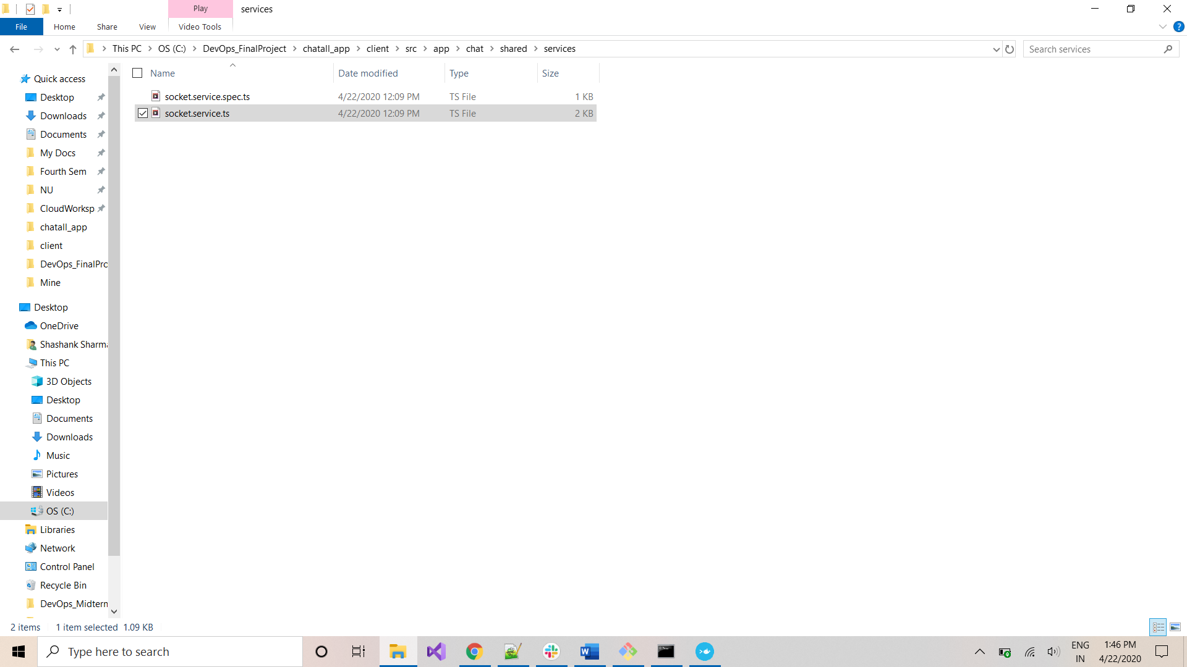

Open the file: *socket.service.ts* in Text-Editor like *Notepad++* and edit the SERVER_URL_AWS property to the External-Ip of backend application captured above:

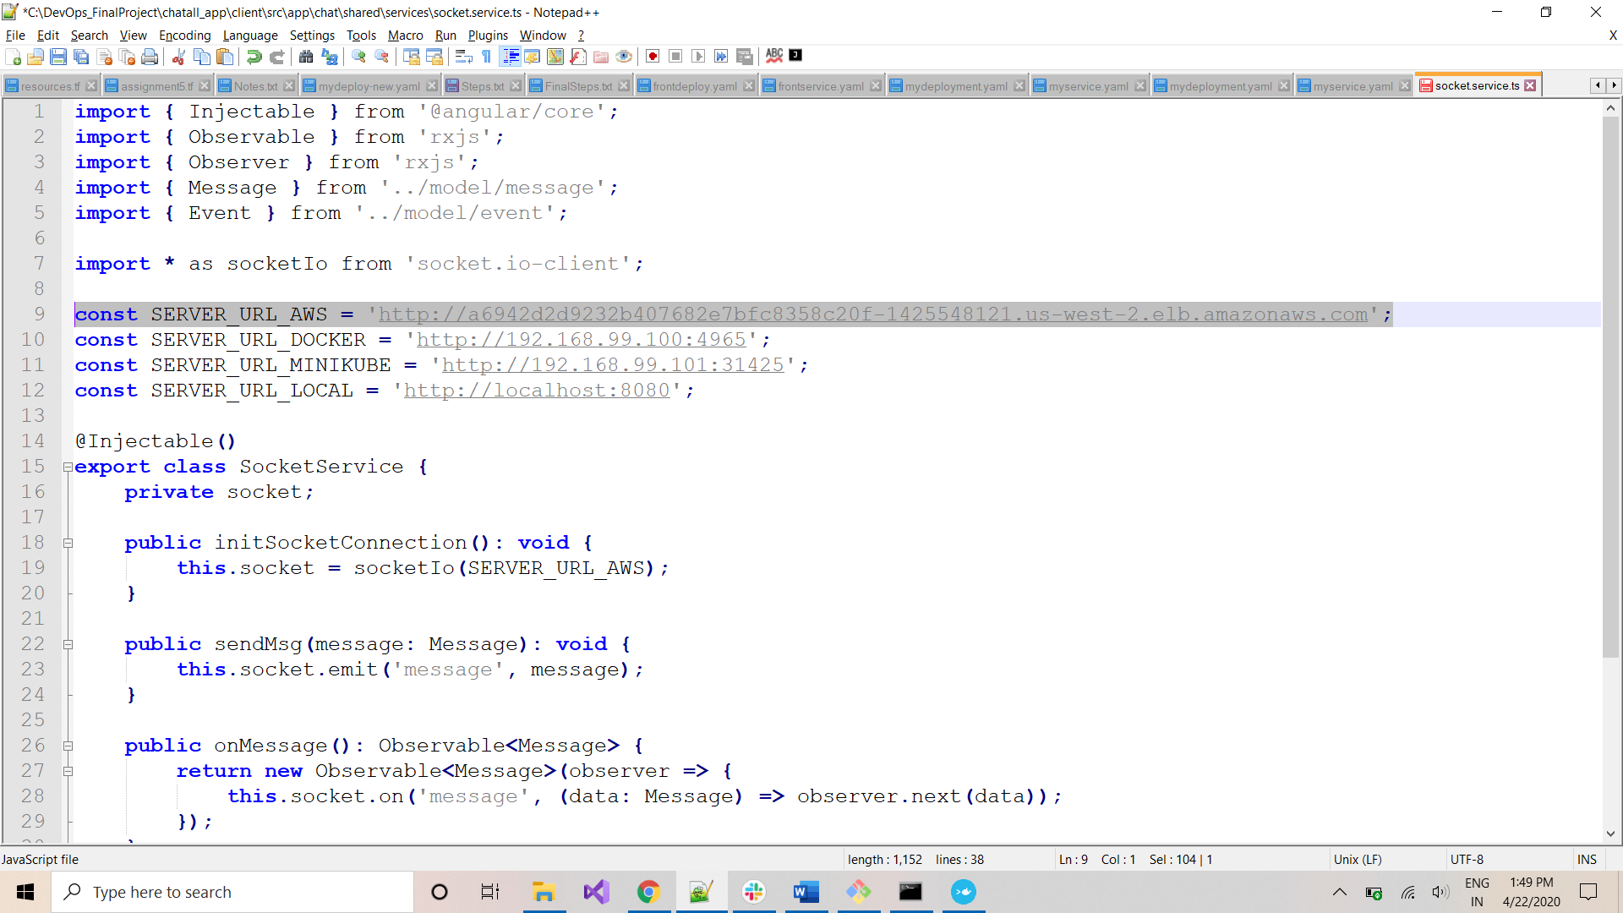

Save the file.

***DOCKERIZING Front-end Application***

Navigate to git-bash to execute the below command to move to client folder:

*cd ../client/*

*ls -al*

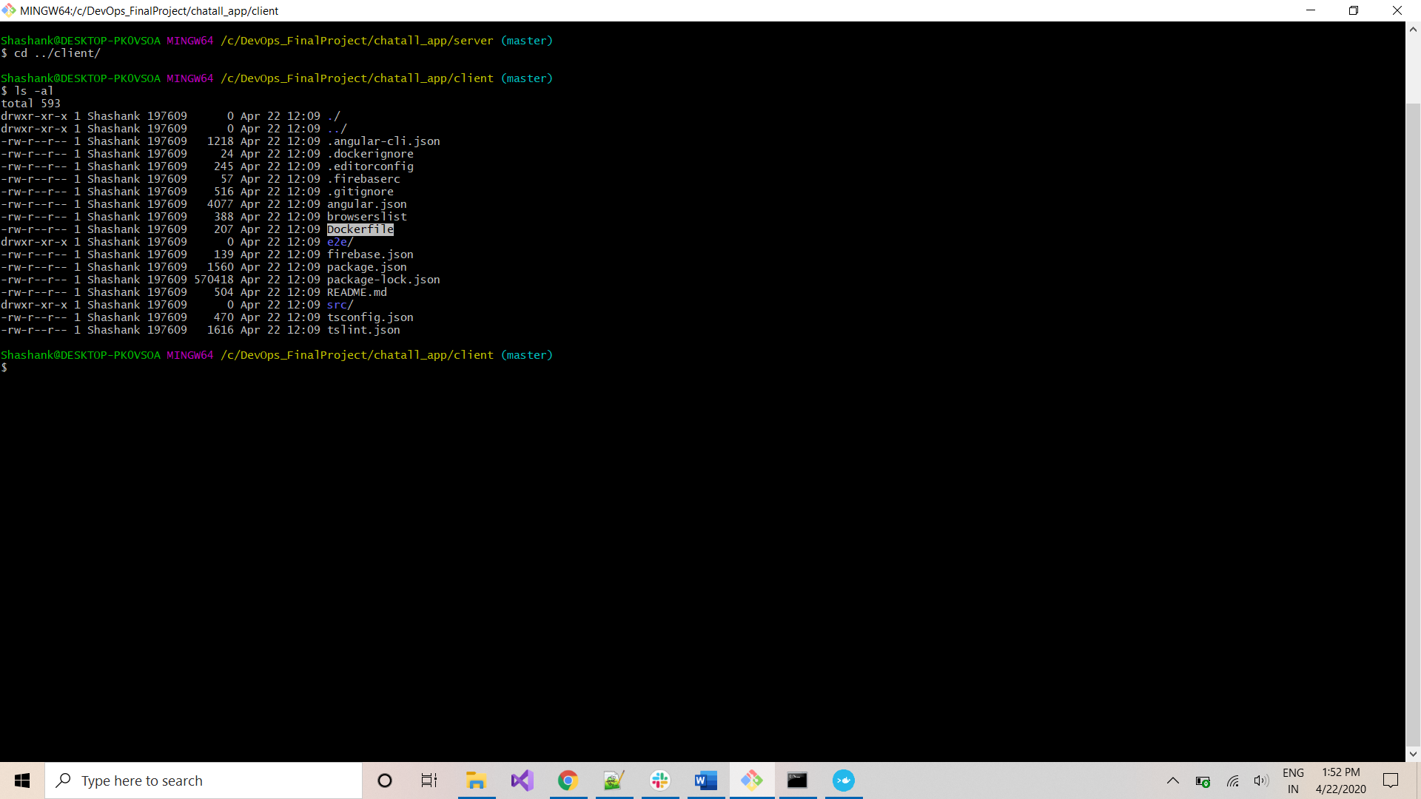

This location has the Dockerfile that will be used to dockerize this app. Execute the below command to create a Docker image for this project and push it to DockerHub:

\**replace ‘sharmashas’ with your dockerhub-ID*

*docker build -t sharmashas/chatclientapp .*

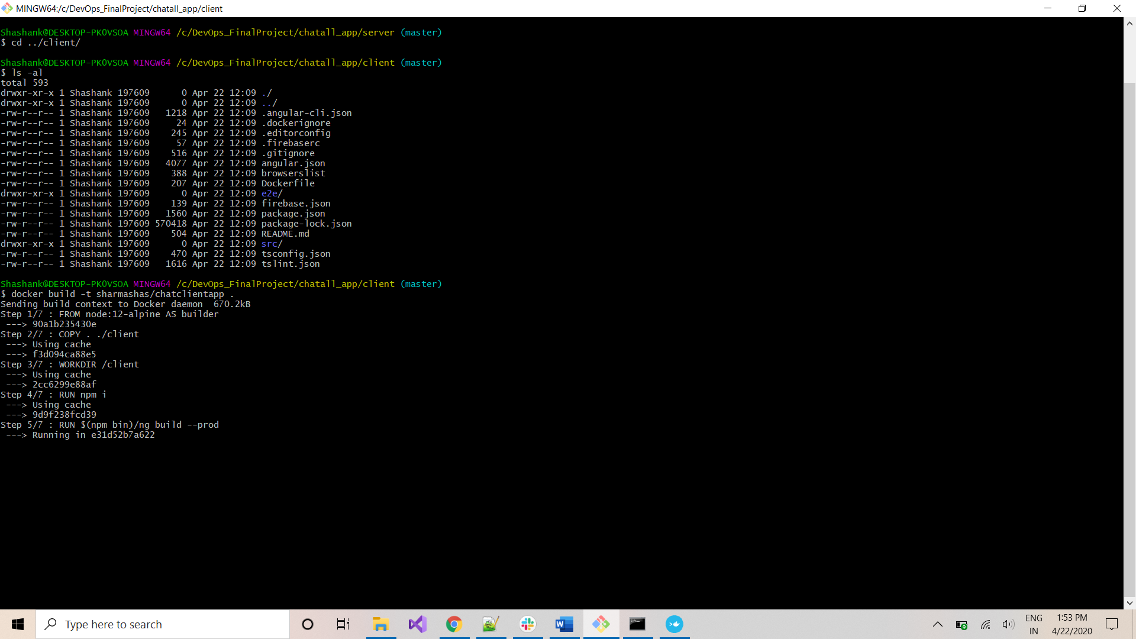

*docker push sharmashas/chatclientapp*

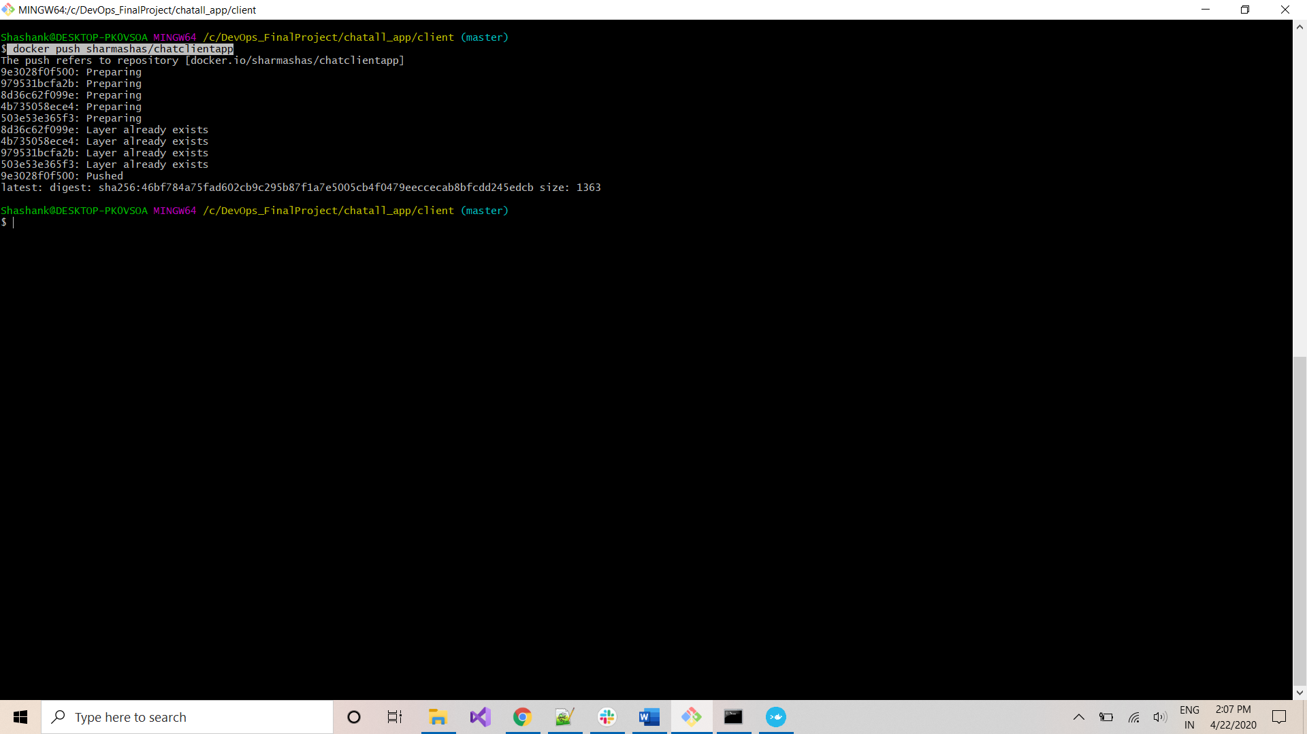

Both the Front-end and Back-end applications are now in your DockerHub account

***DEPLOY Front-end Application to CLUSTER***

Navigate to folder: C:\DevOps_FinalProject\chatall_app\aws-eks-terraform\pods_yaml

& Open *frontdeploy.yaml* in a text-editor like Notepad++ and specify the dockerhub image at below location:

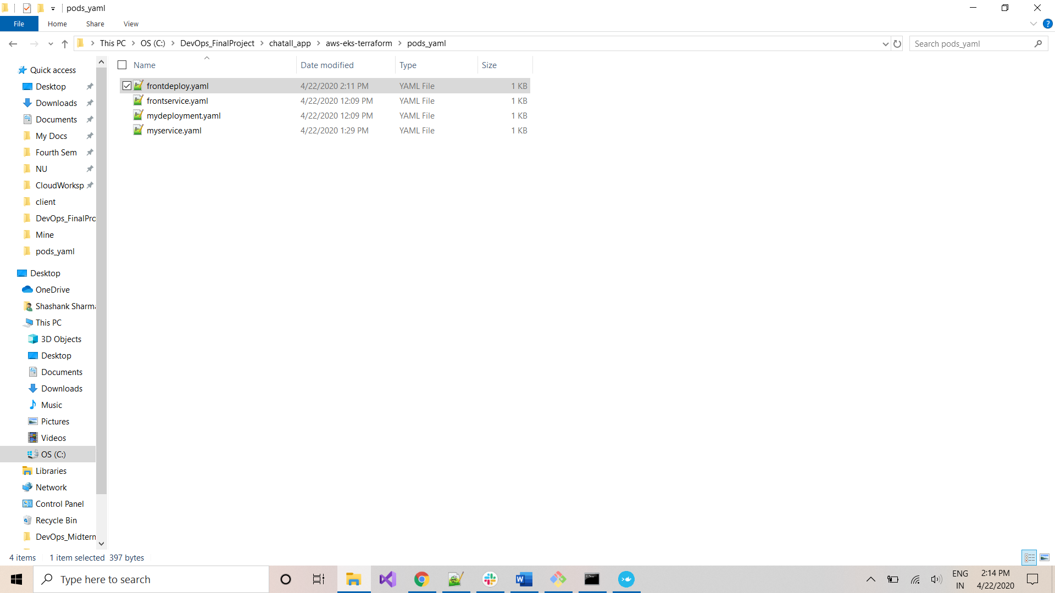

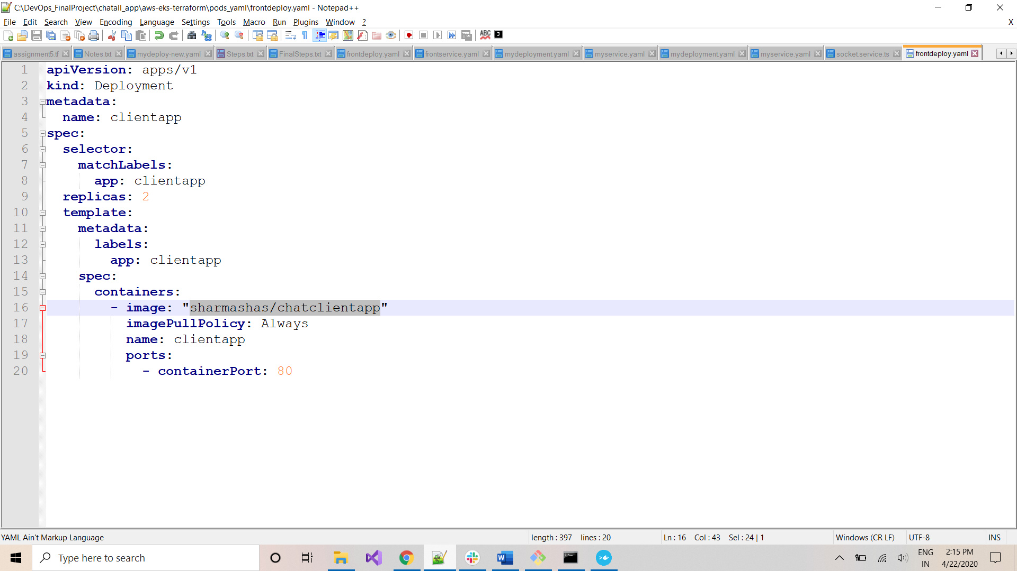

Navigate to Command-Prompt on this location and execute the below command to deploy pods for Front-end:

*kubectl apply -f frontdeploy.yaml*

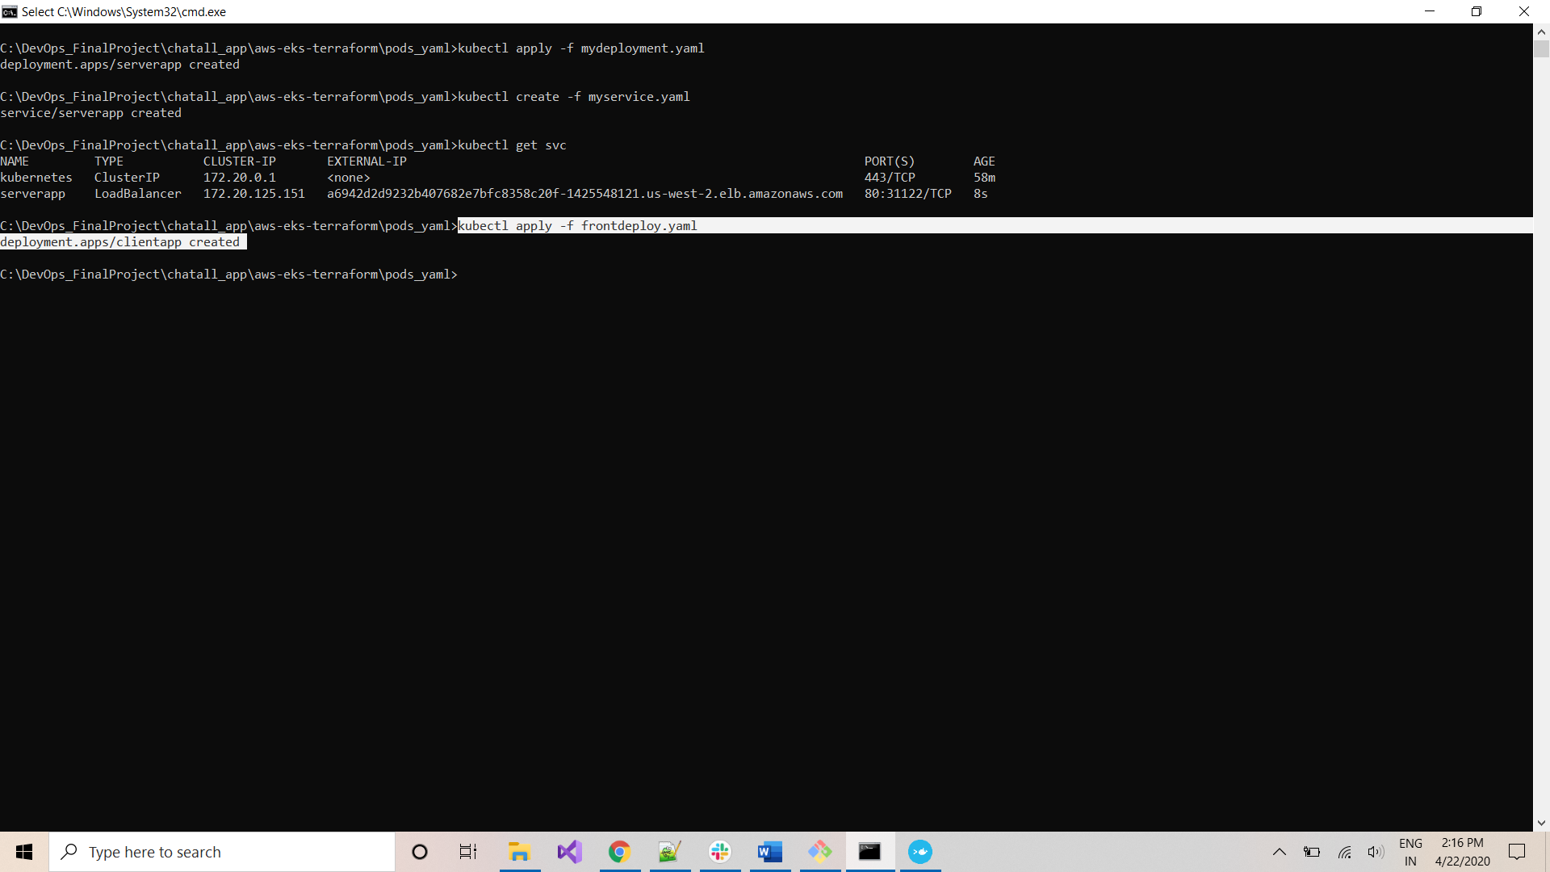

Execute below command to create service for Front-end:

*kubectl create -f frontservice.yaml*

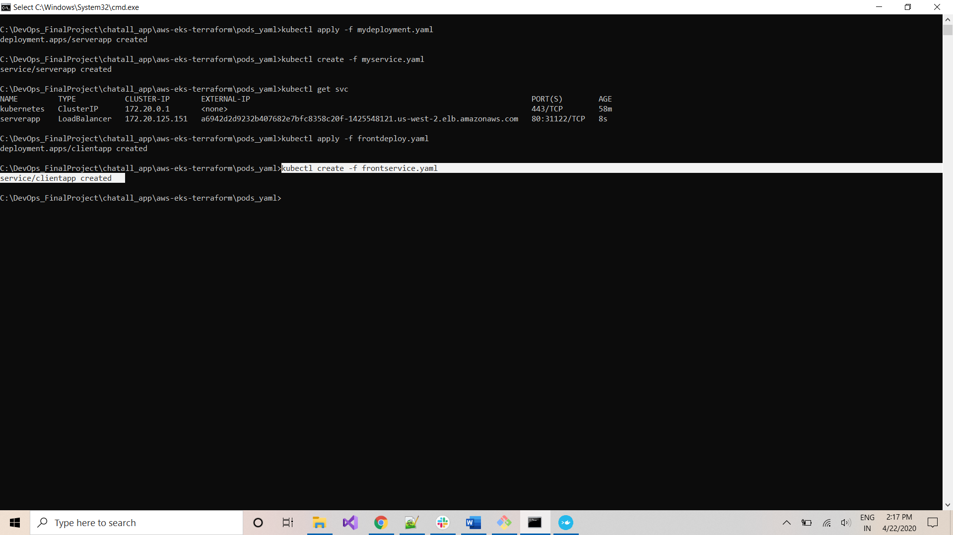

Execute the below command to all services running in the cluster:

*kubectl get svc*

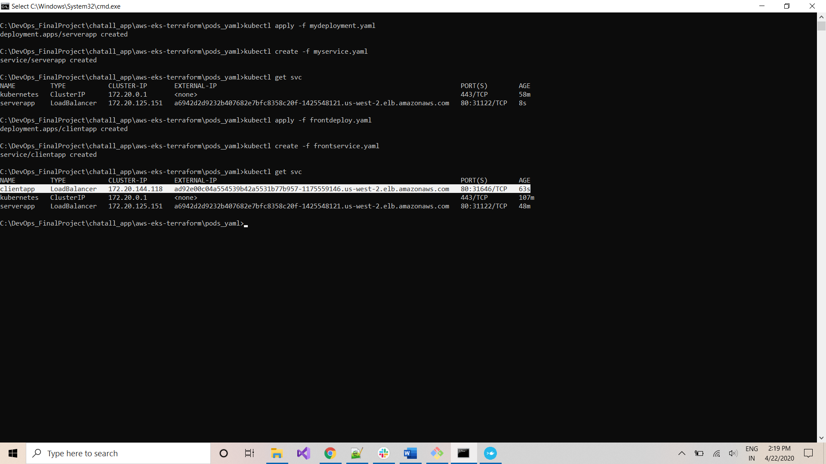

Capture the *External-IP* for front-end service:

*External-IP: ad92e00c04a554539b42a5531b77b957-1175559146.us-west-2.elb.amazonaws.com*

***ACCESS Front-end Application from ANYWHERE***

The application can be accessed from anywhere using the *External-IP* for front-end using the below link:

<http://ad92e00c04a554539b42a5531b77b957-1175559146.us-west-2.elb.amazonaws.com/>

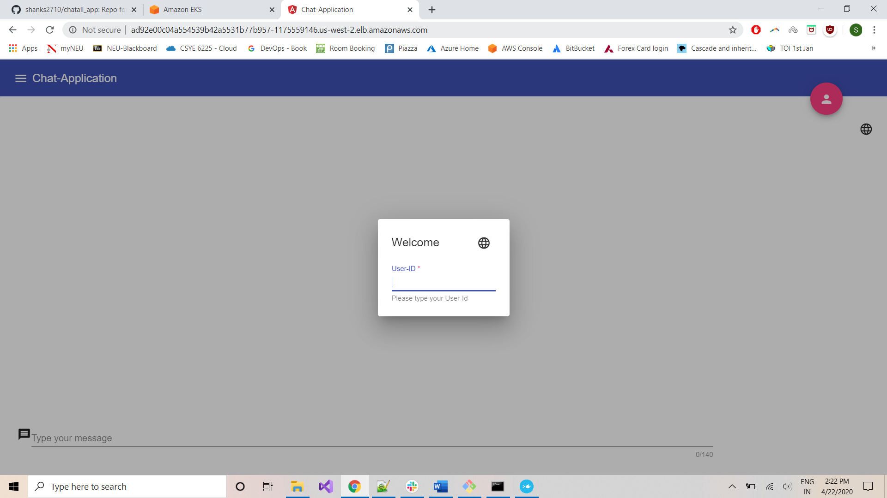

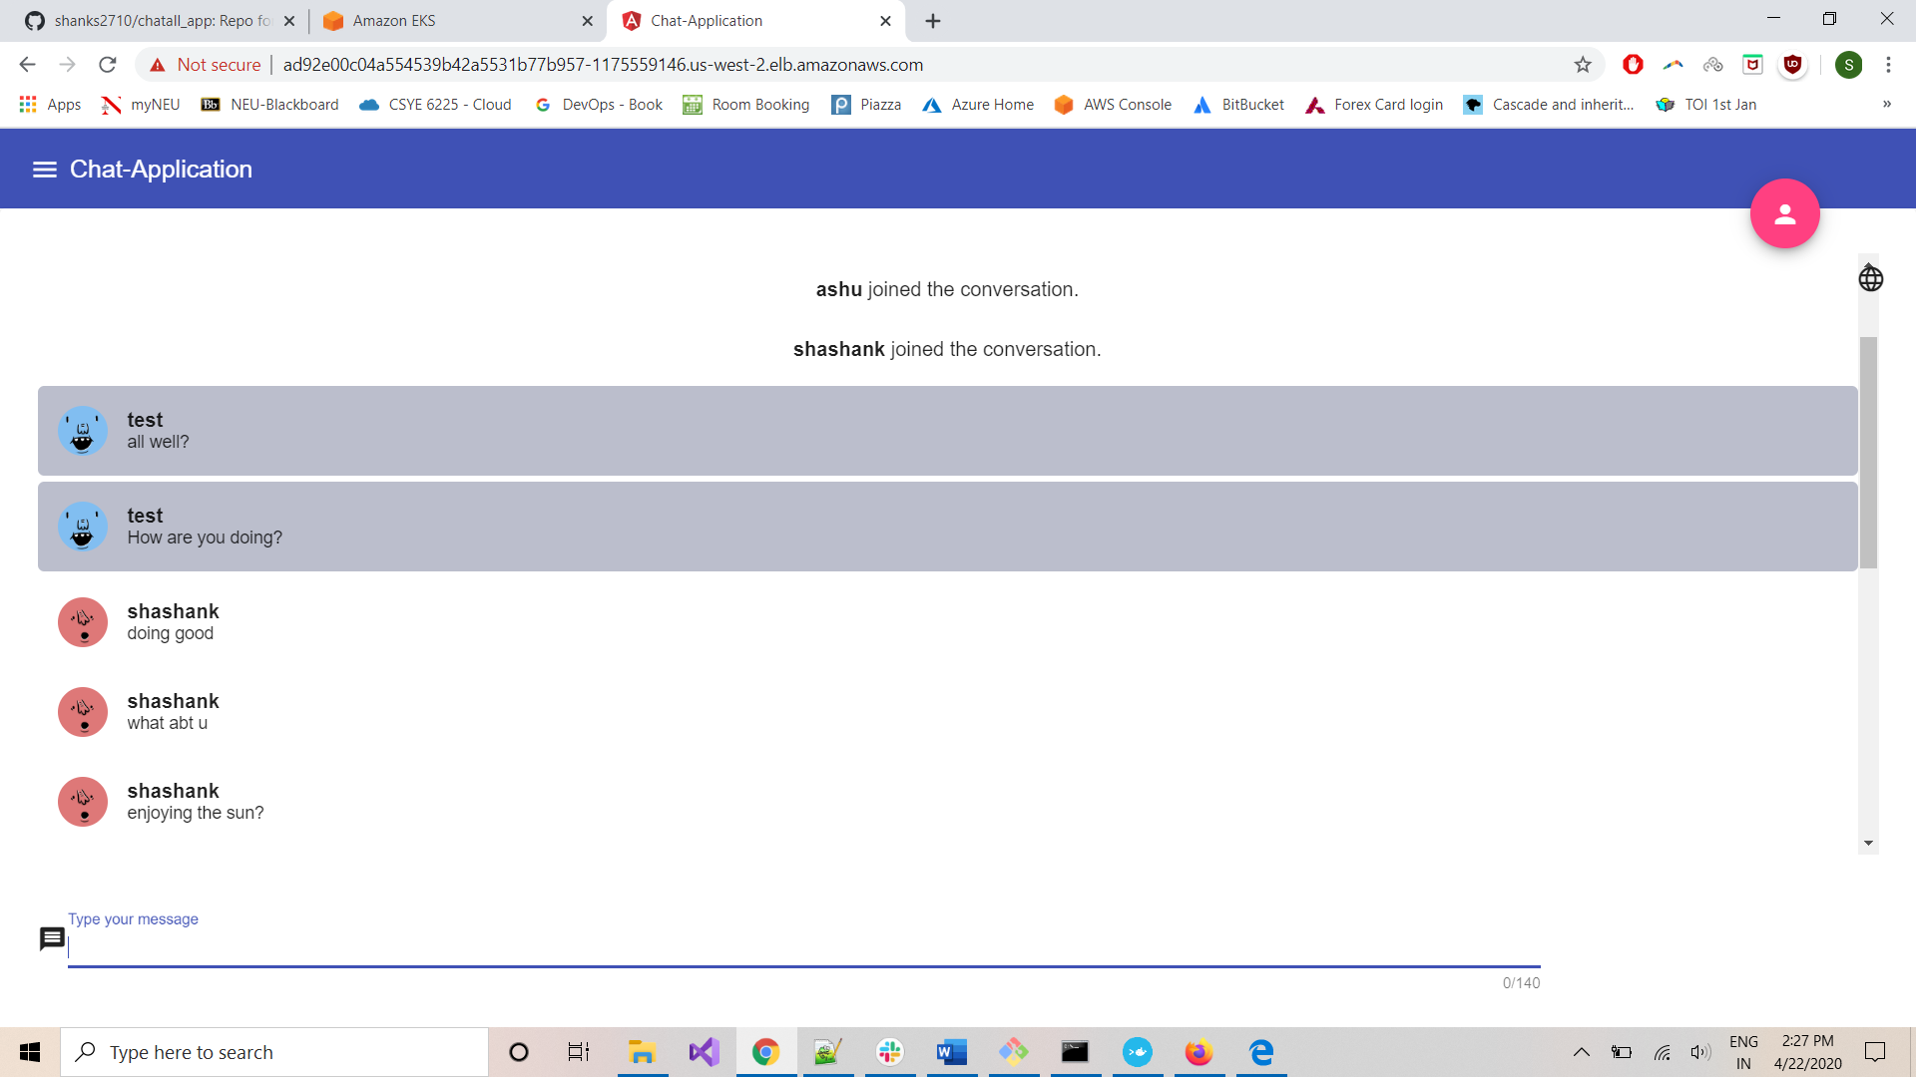

***MONITORING CLUSTER using GRAPHANA***

\**Ensure you have HELM v3.1.2 installed on your system for this section*

Go to Command-Prompt and execute the below command to set Prometheus-repo for HELM:

*helm repo add stable https://kubernetes-charts.storage.googleapis.com*

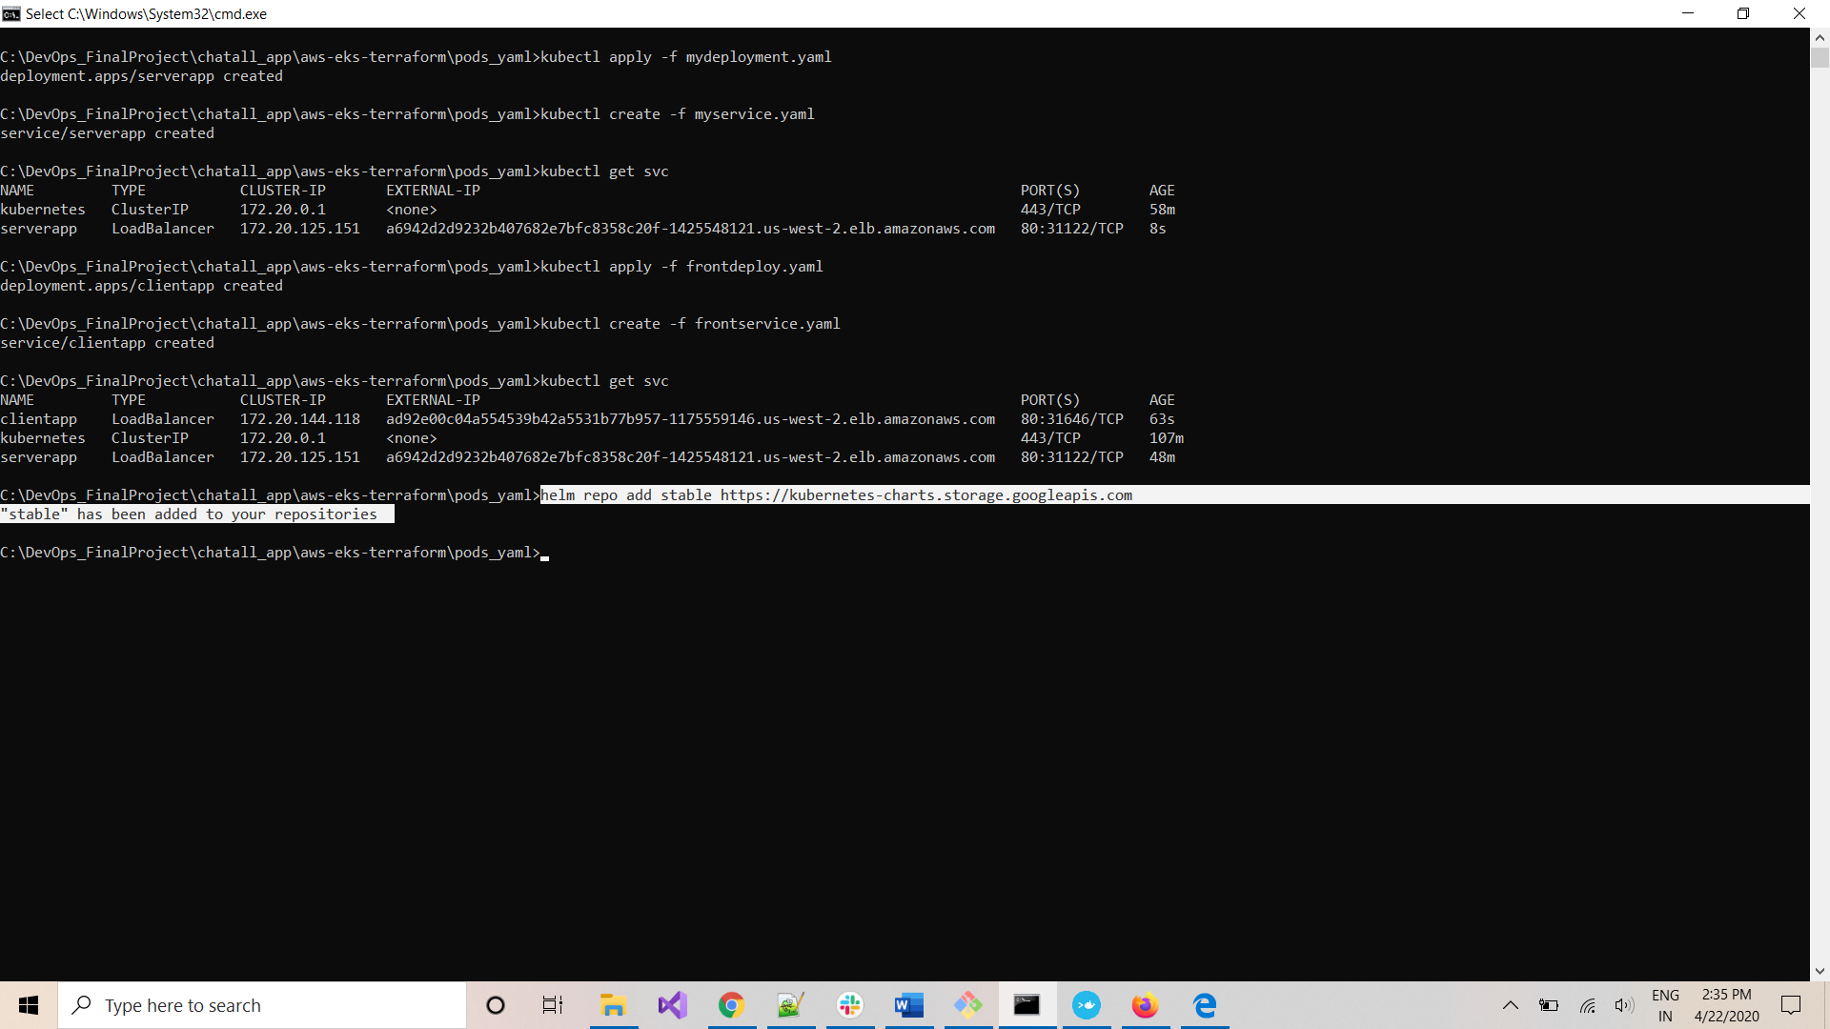

Execute below command to install Prometheus and graphana pods on your cluster:

*helm install shashank-prometheus-operator stable/prometheus-operator*

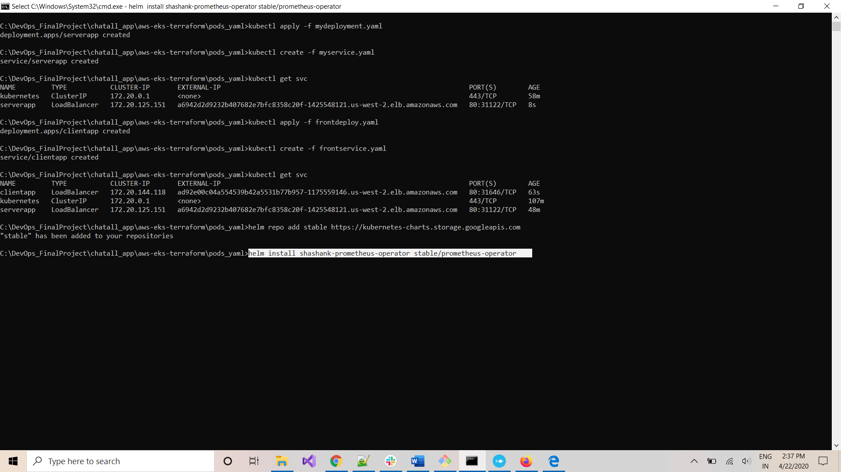

Once the install is complete and service is deployed, execute below command to get monitoring services running on cluster:

*kubectl get svc*

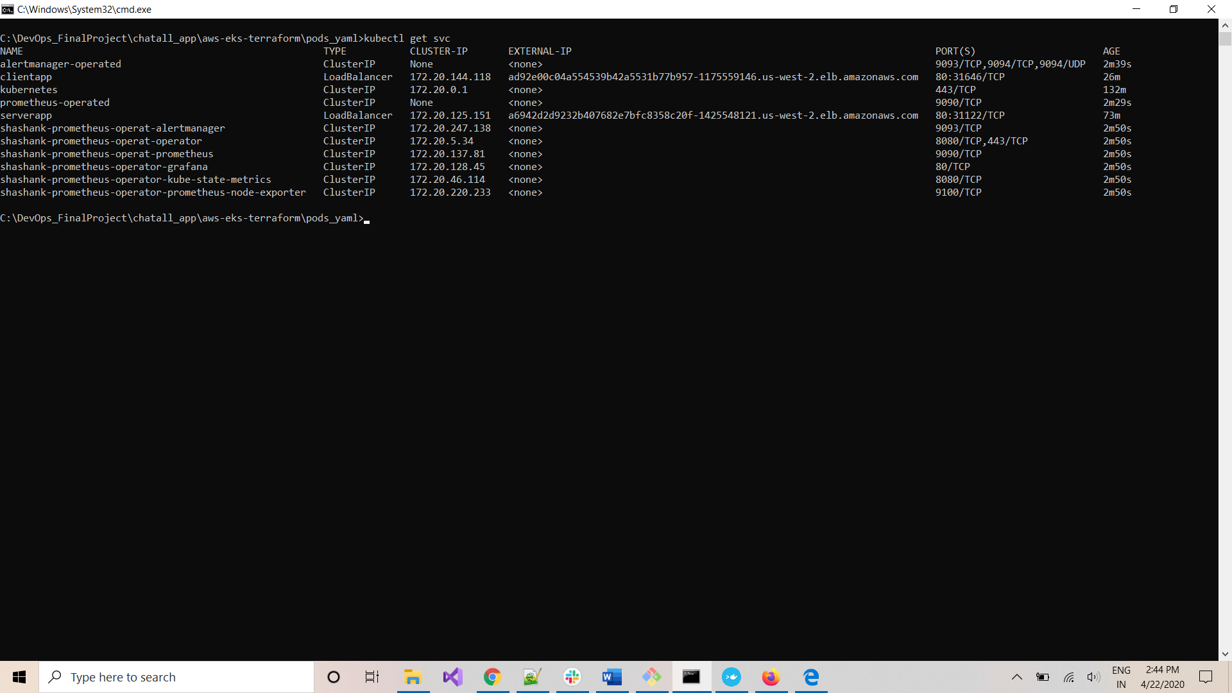

Execute below command to get pods running on the cluster:

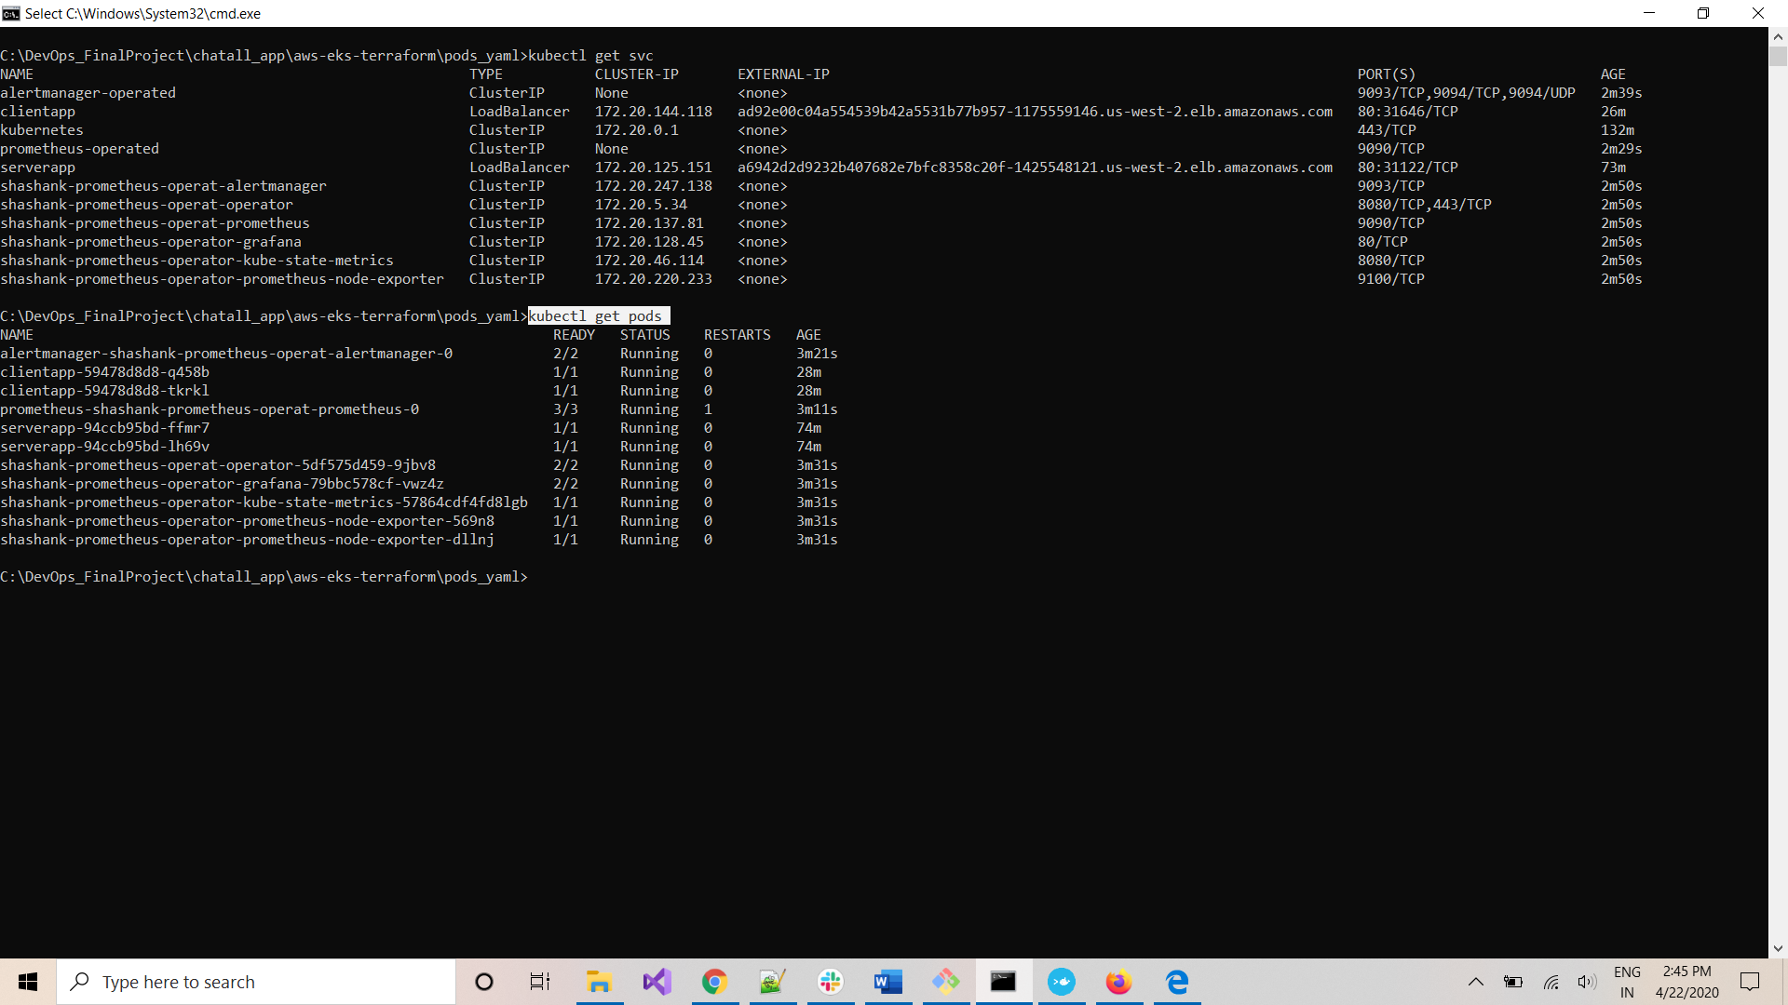

Notice the Graphana pod running on cluster:

*Pod-Name: shashank-prometheus-operator-grafana-79bbc578cf-vwz4z*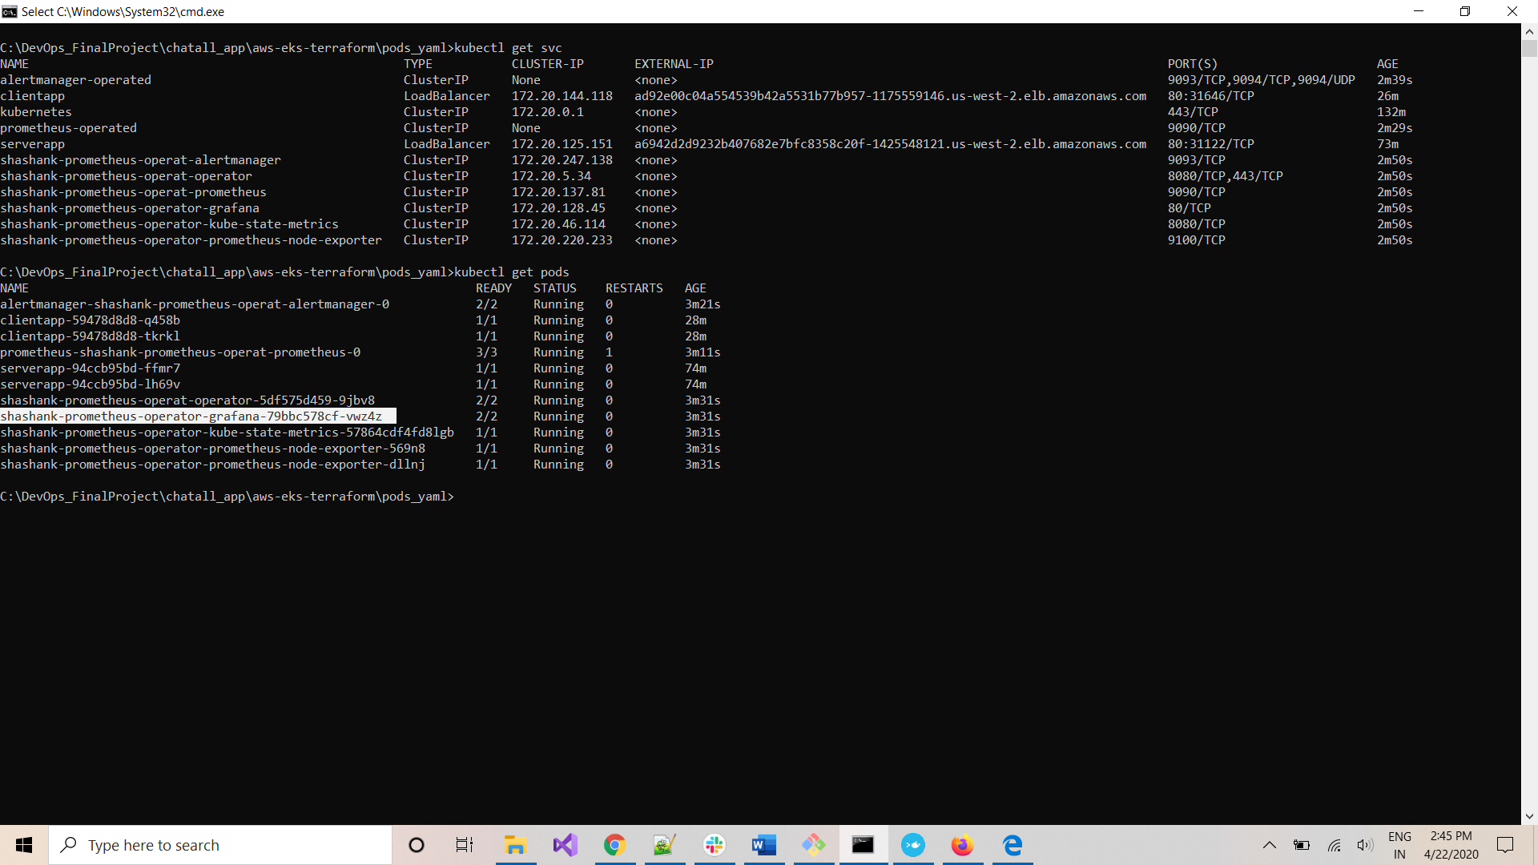

Execute the below command to access Graphana from your machine:

*kubectl port-forward shashank-prometheus-operator-grafana-79bbc578cf-vwz4z 3000*

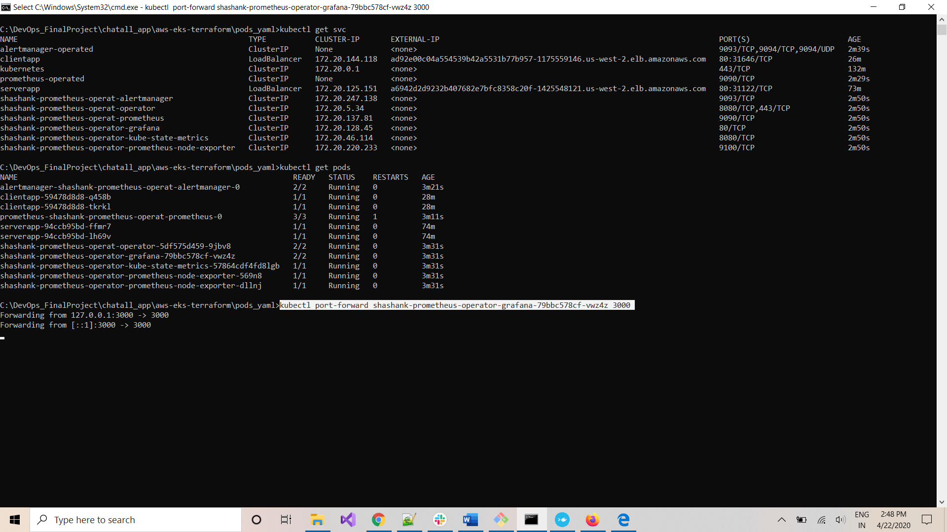

*Open any browser and go to link:* [*http://localhost:3000*](http://localhost:3000)

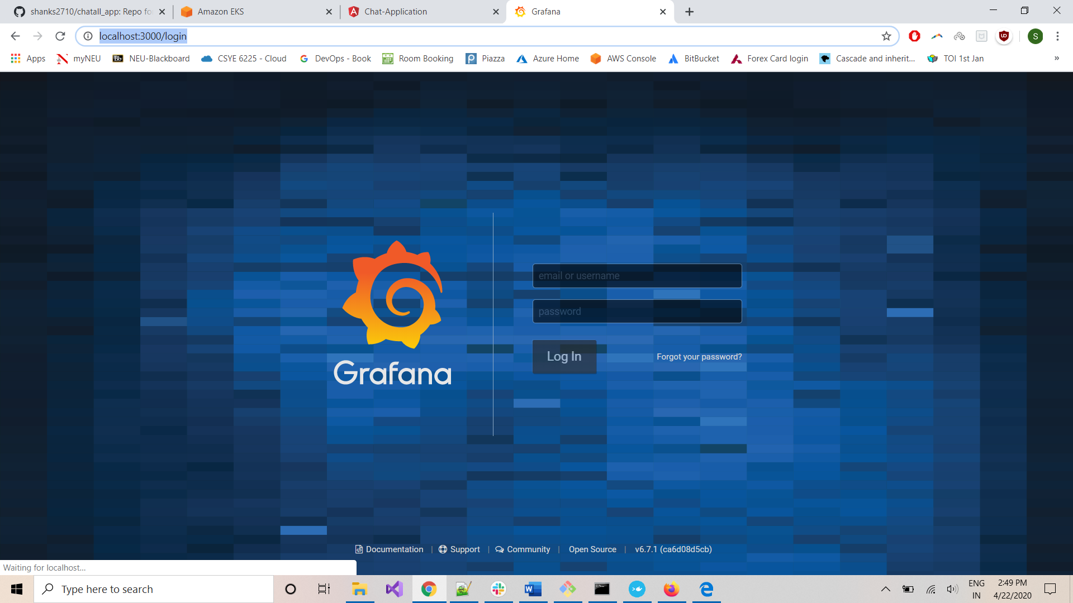

*Login with below credentials:*

*Username: admin*

*Password: prom-operator*

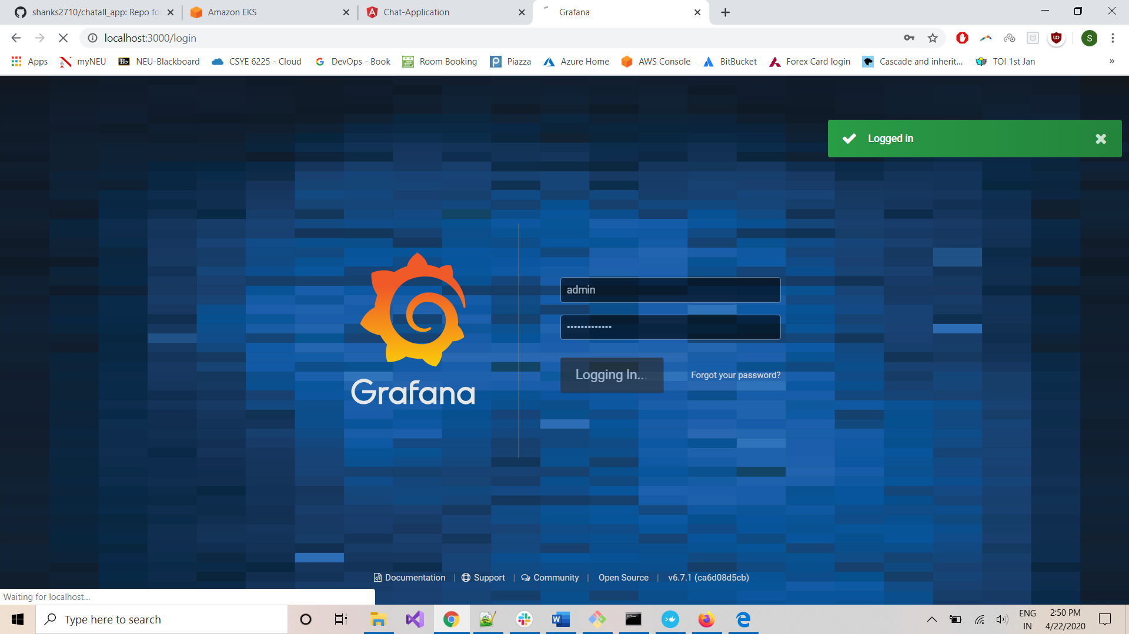

*You can access different dashboards for your cluster:*

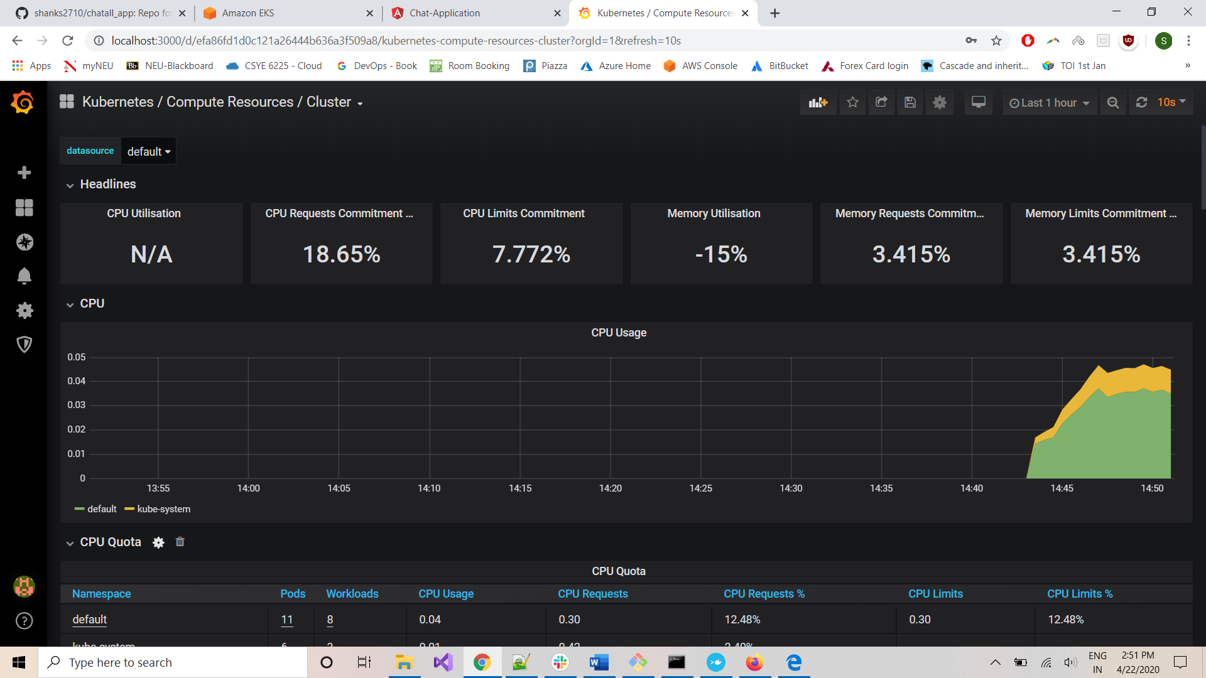

***DESTROY CLUSTER***

Open Command-Prompt and do Ctrl+C to stop port forwarding for graphana-pod:

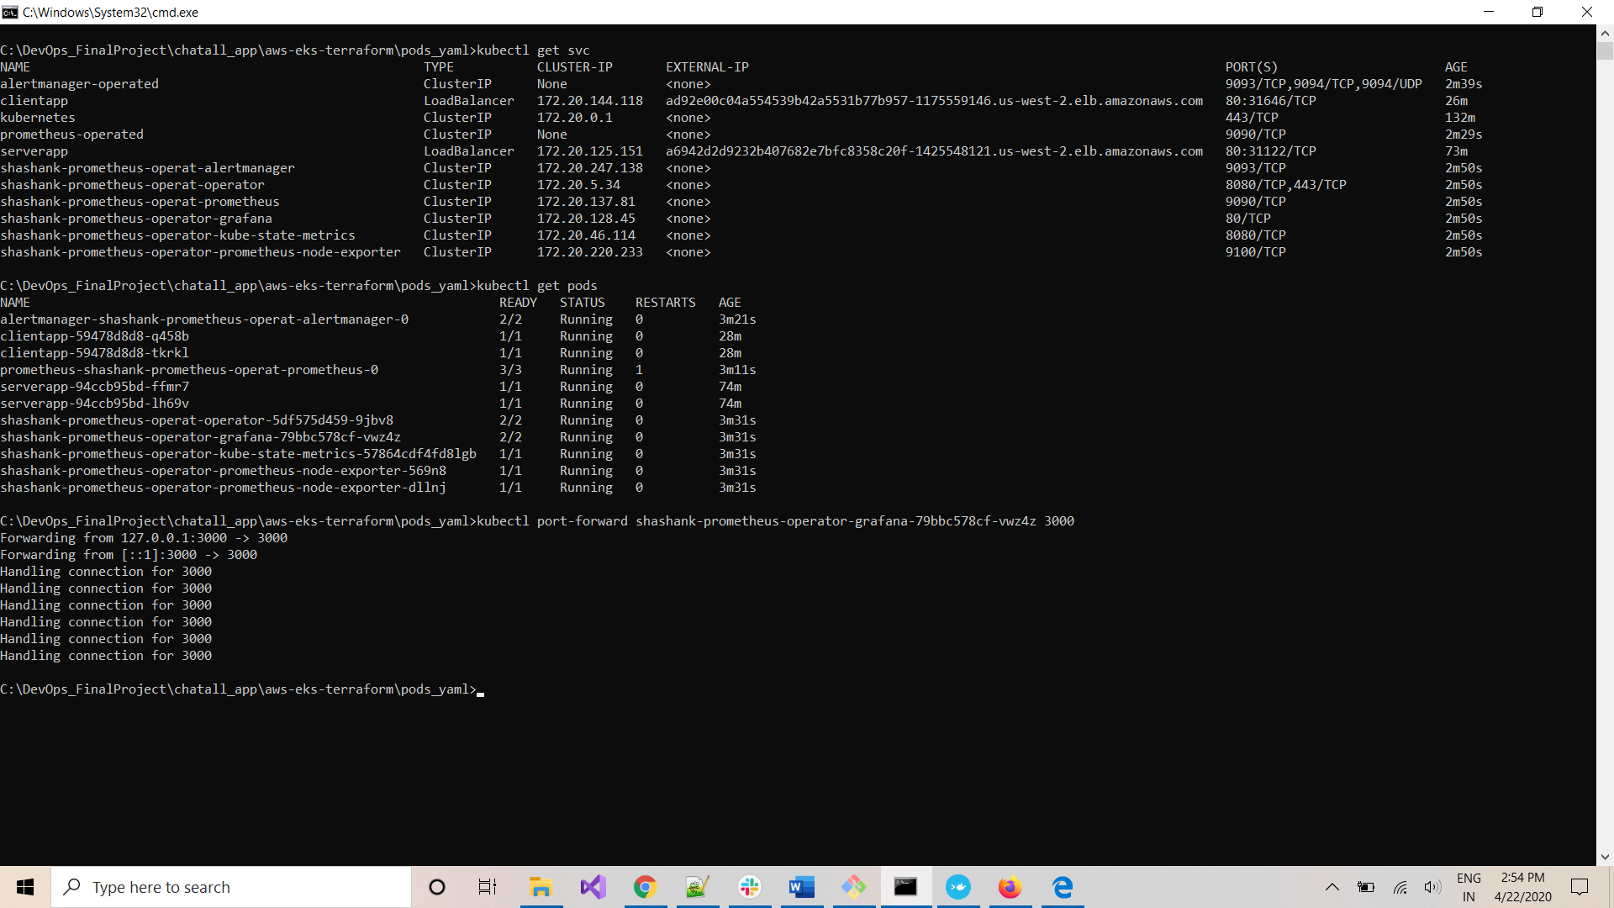

Execute below command to get to ‘aws-eks-terraform’ folder:

*cd ..*

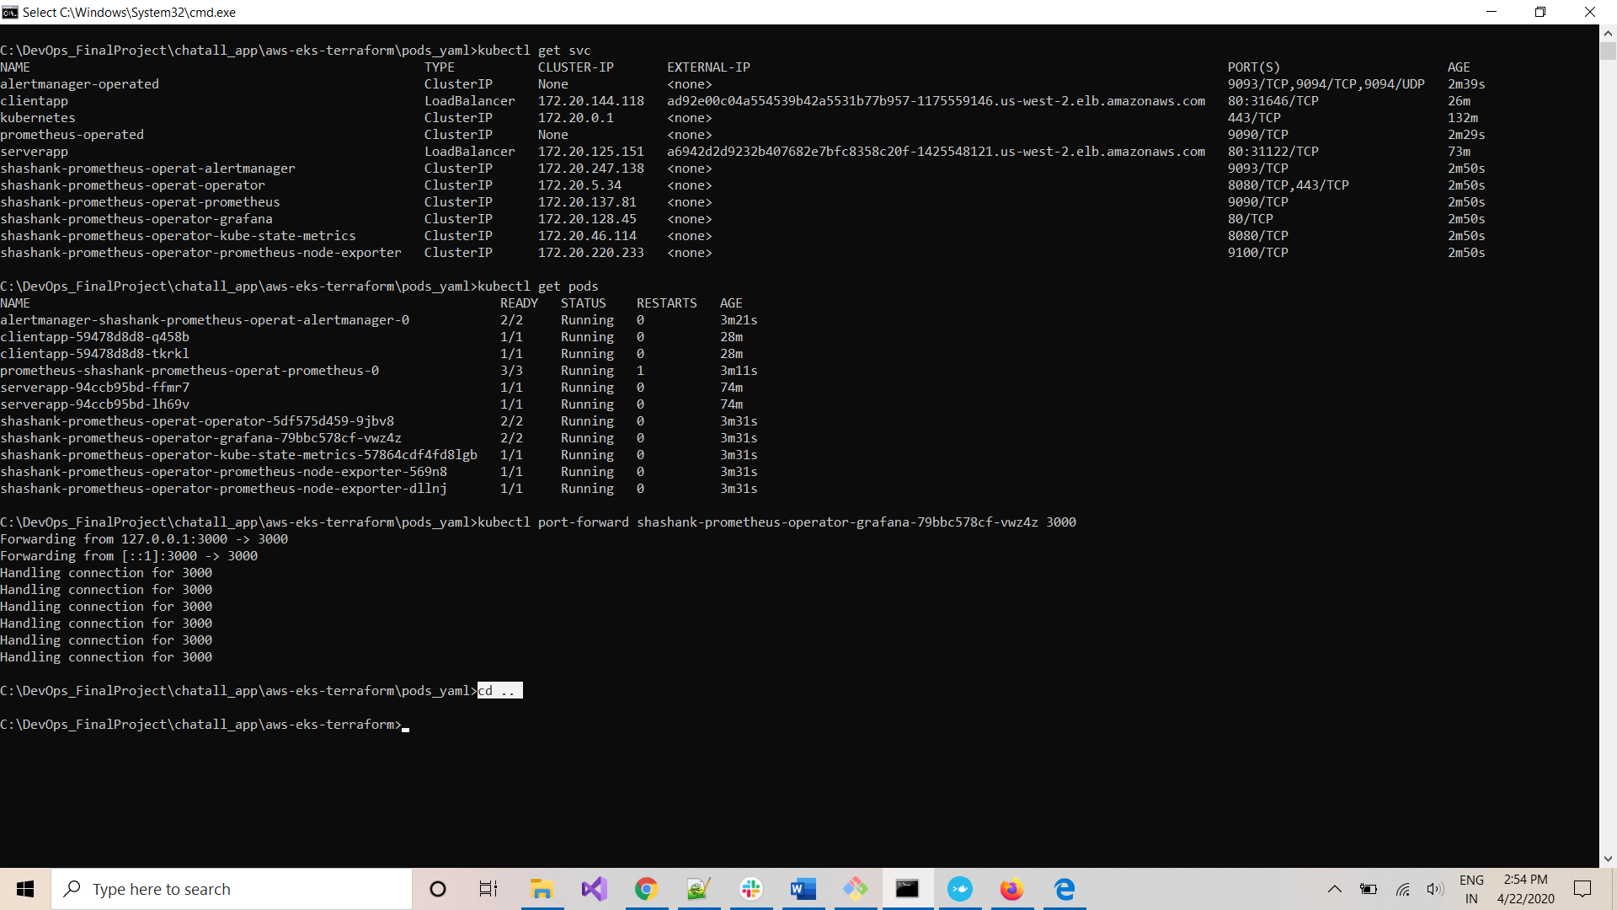

Execute the below command to destroy the cluster:

*terraform destroy*

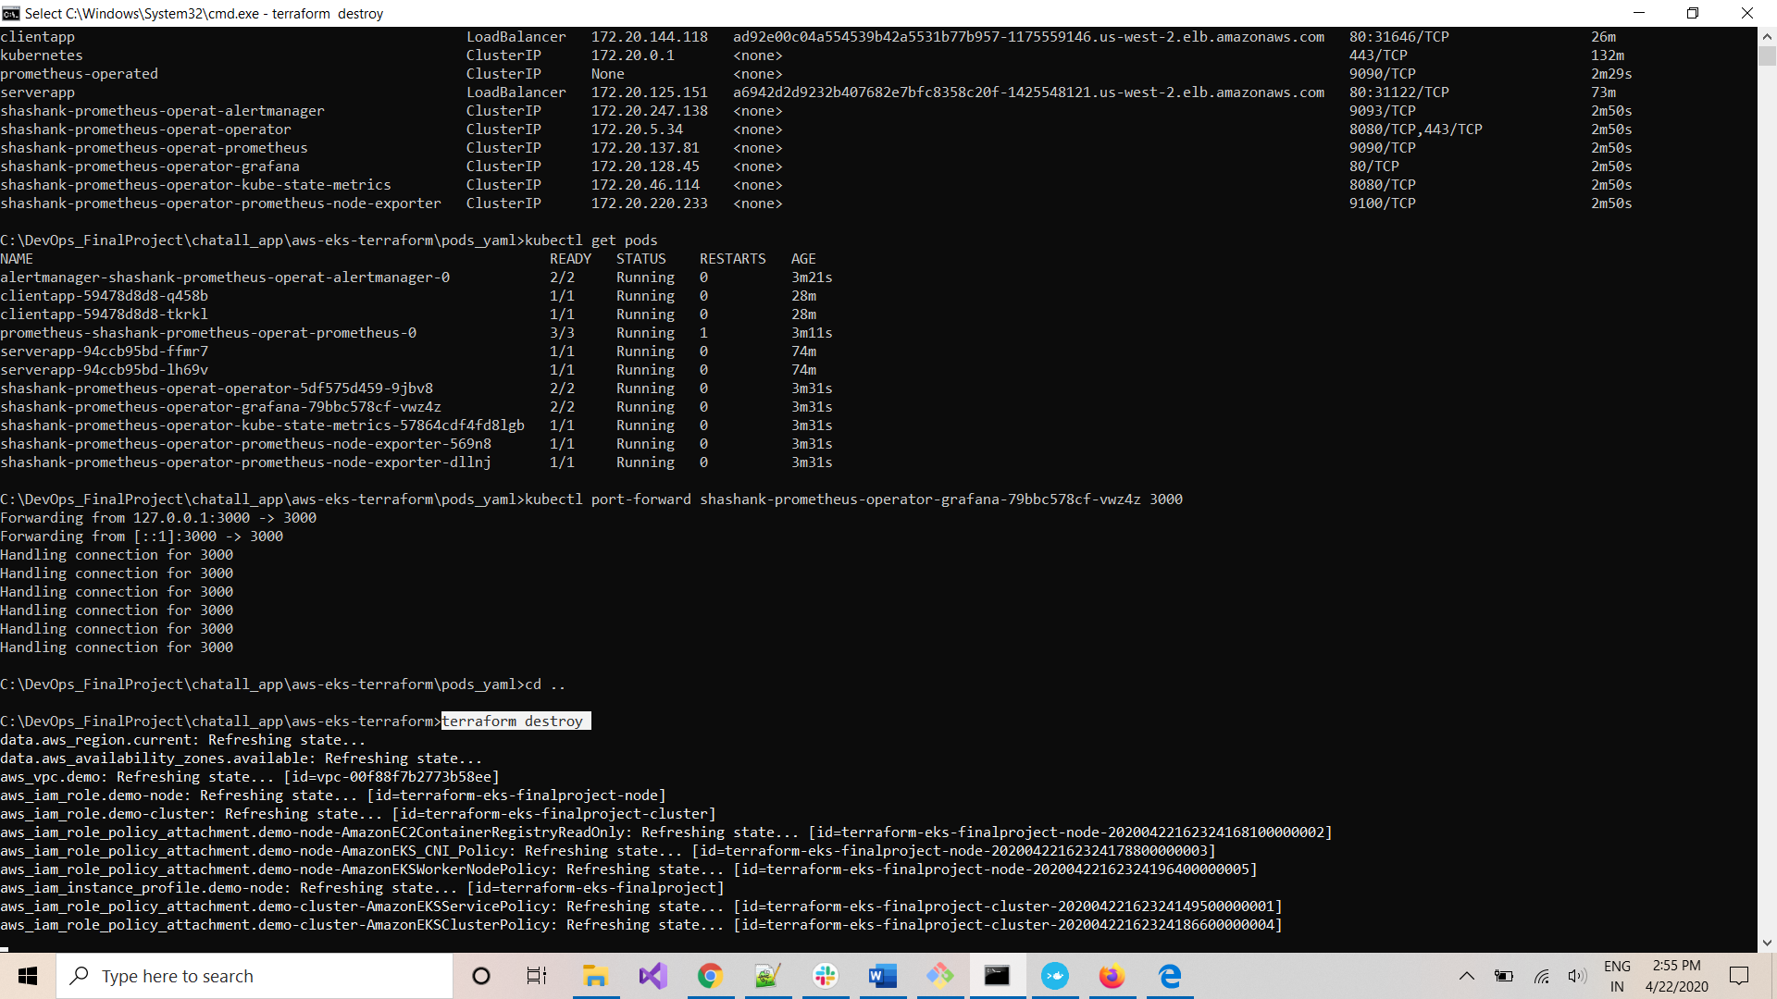

Enter ‘*yes’* when prompted and click Enter:

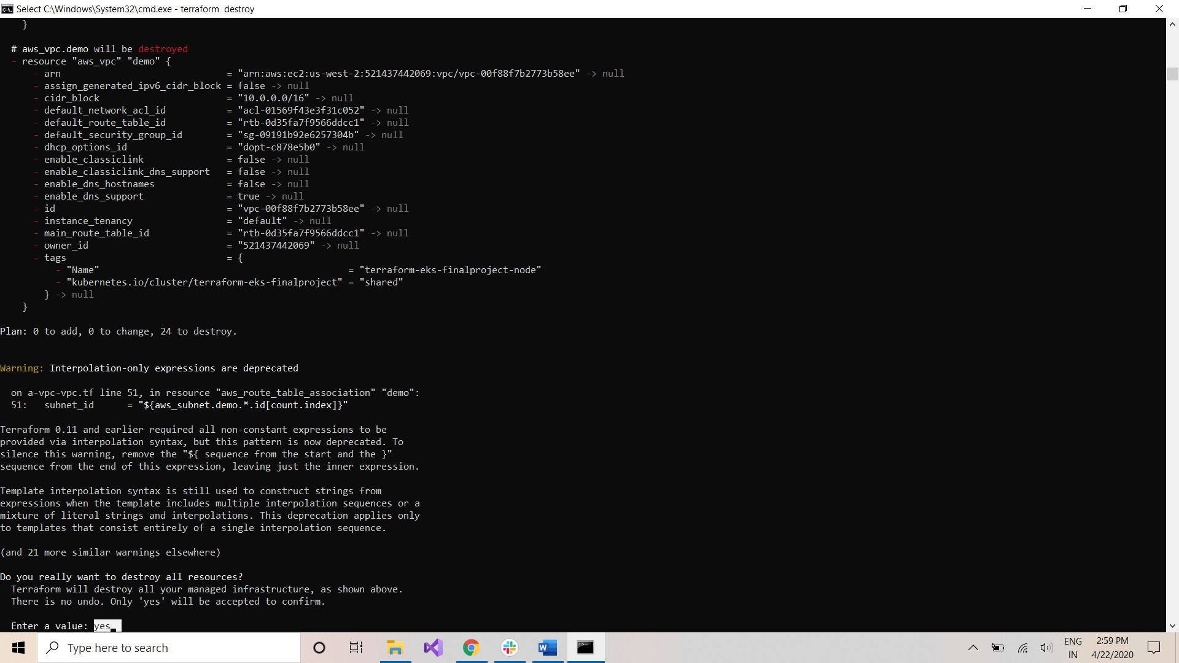

Cluster is being destroyed:

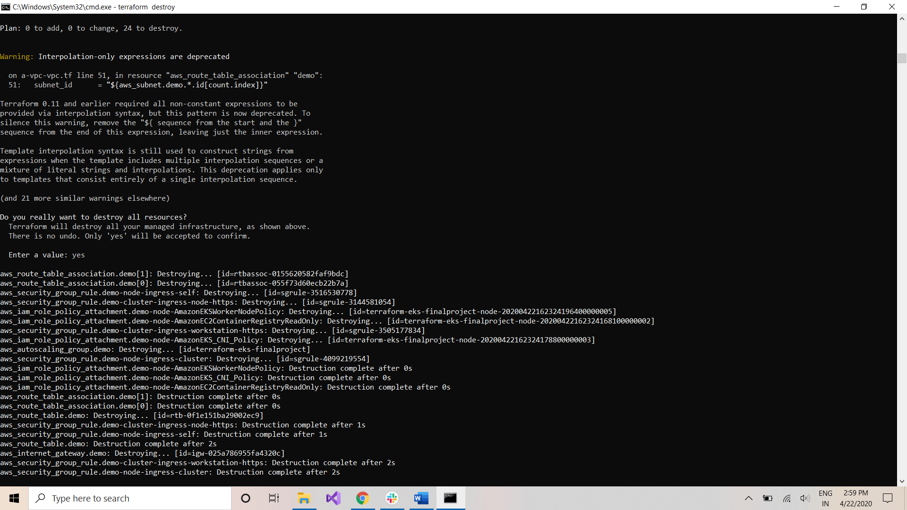

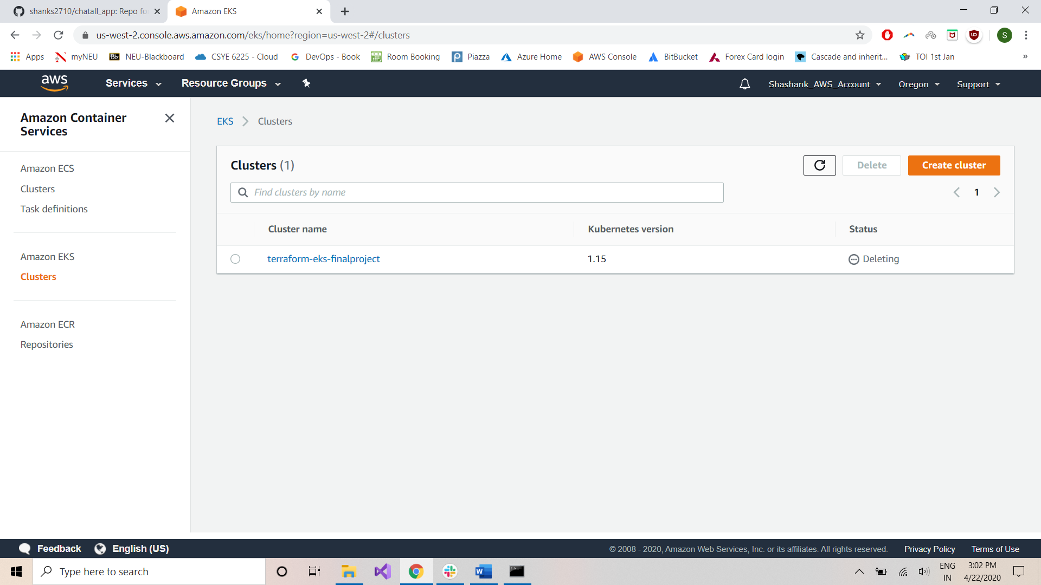

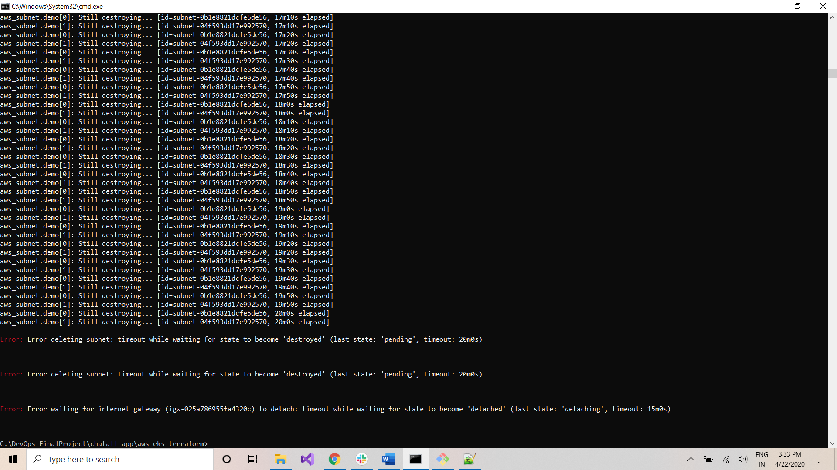

If terraform is unable to delete all resources, got to AWS console:

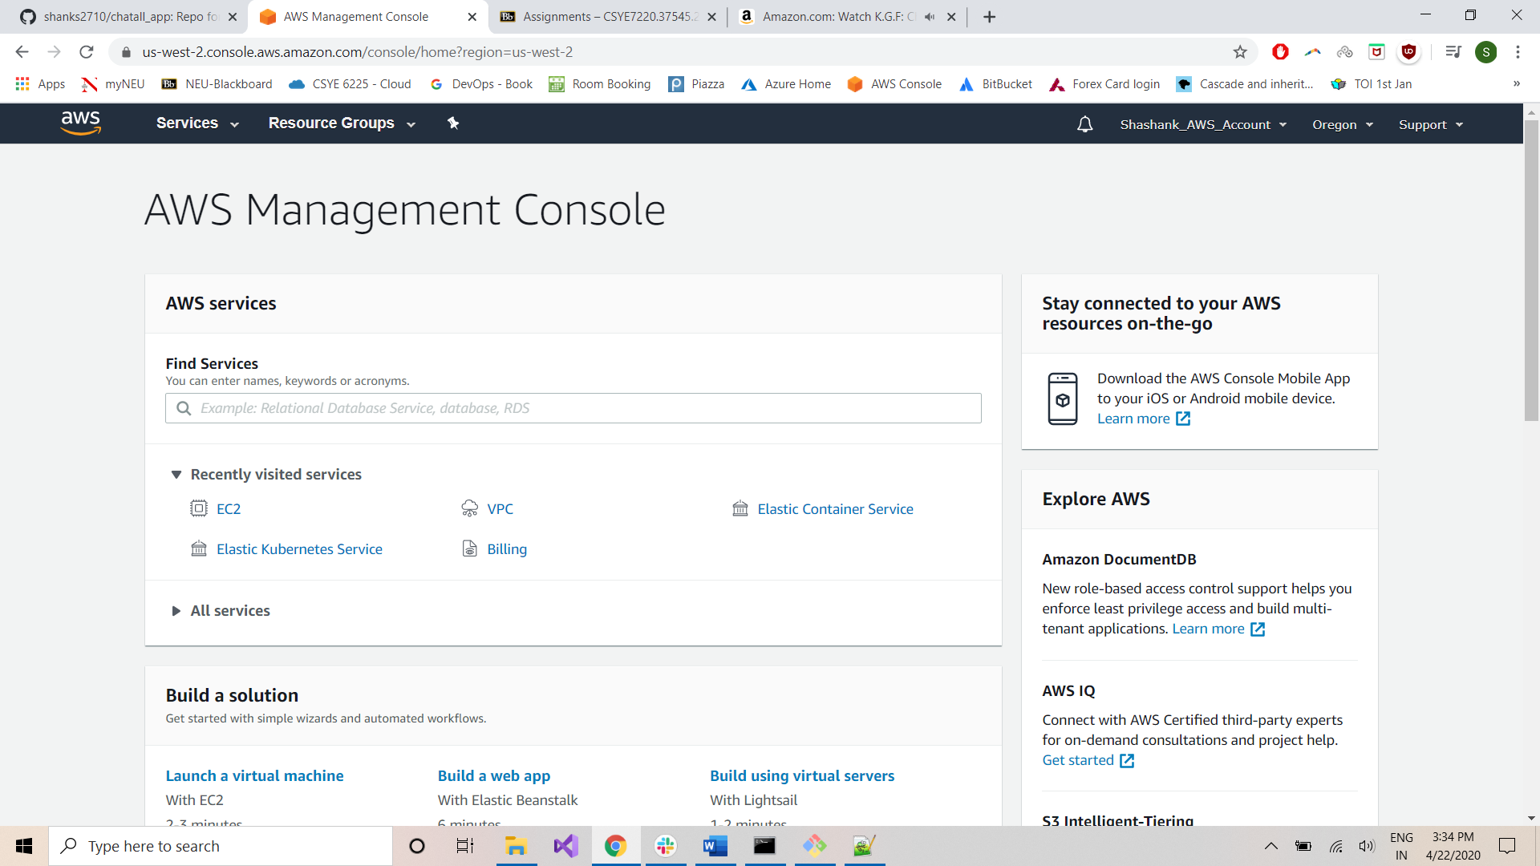

Navigate to EC2->Load Balancers

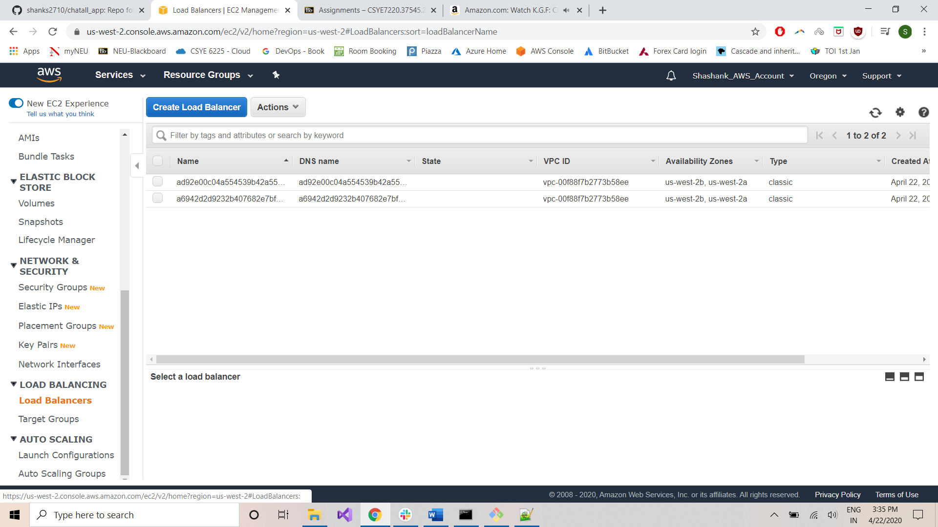

Delete these resources:

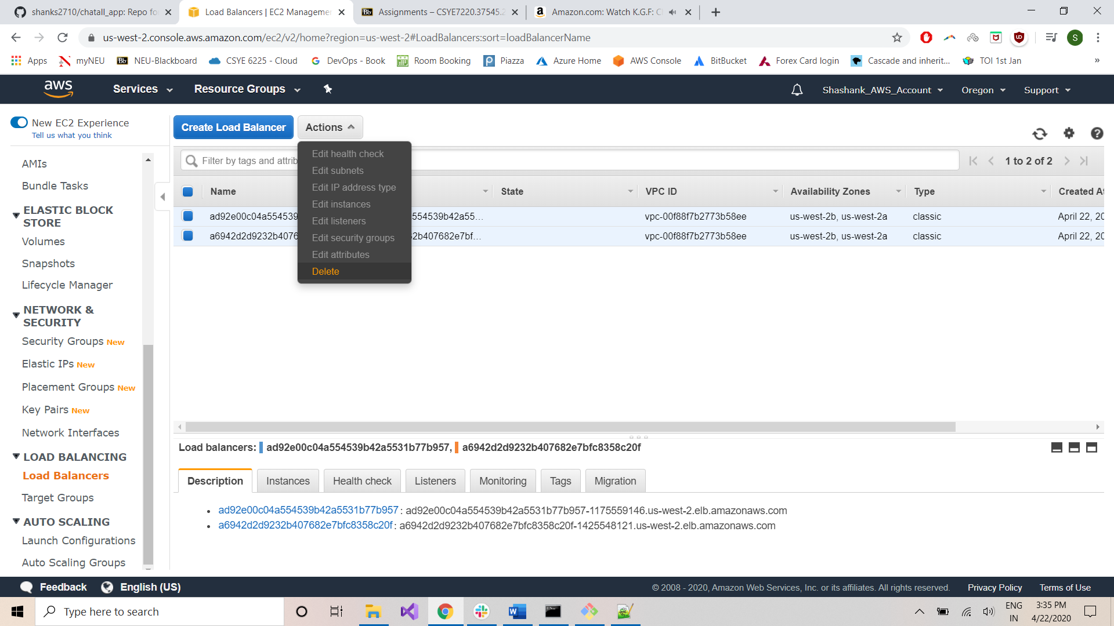

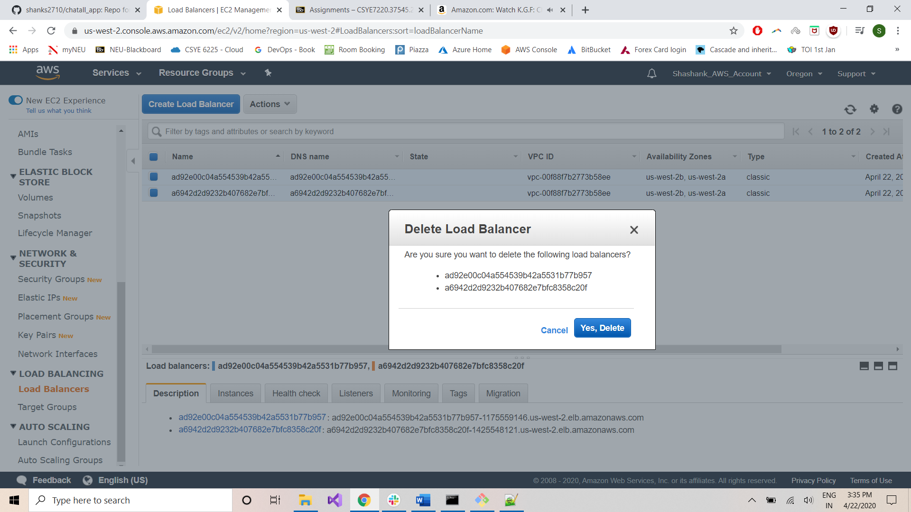

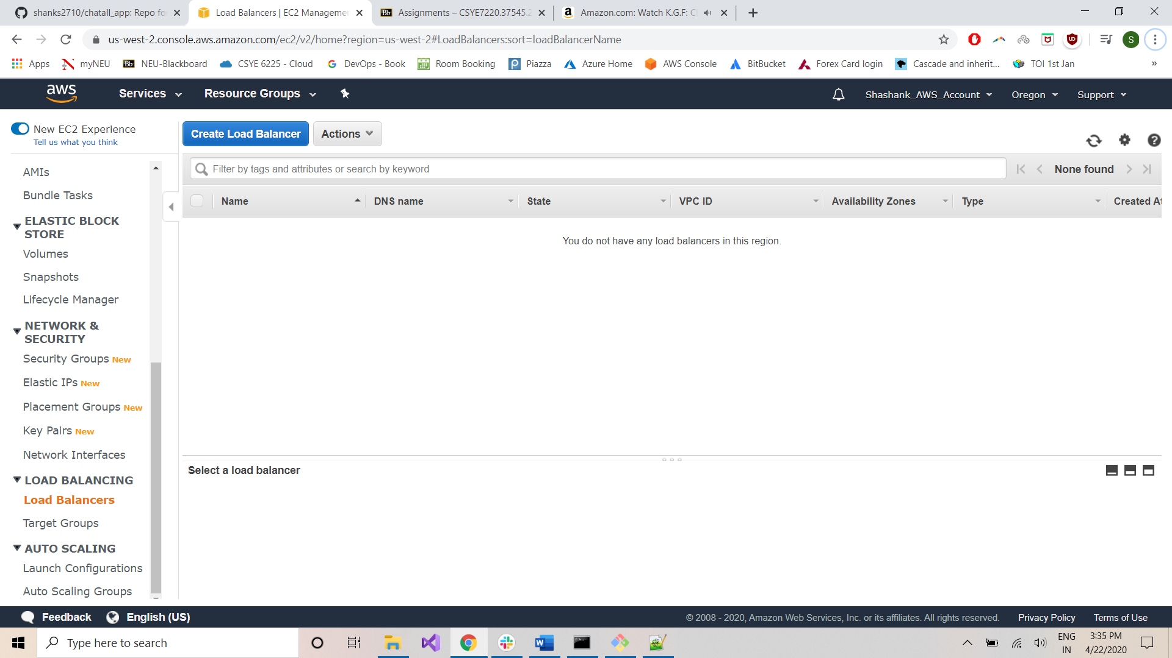

Go to VPC:

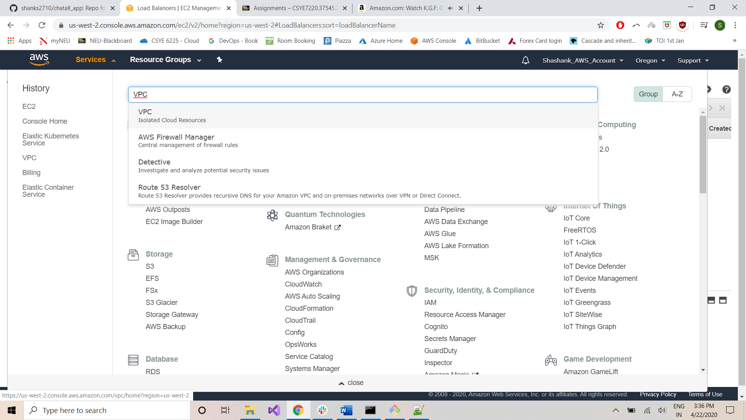

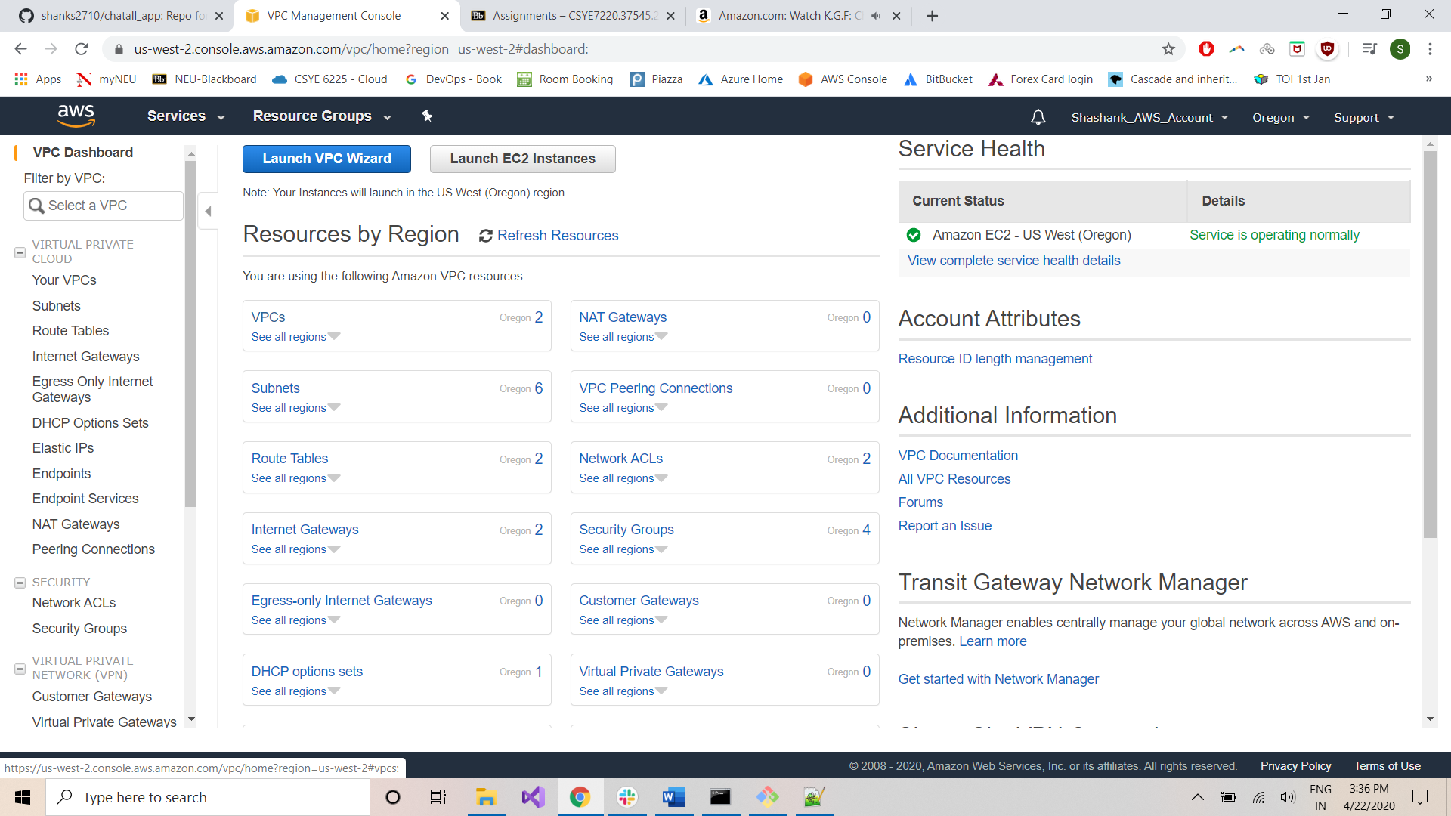

Select the VPC created with name *‘terraform-eks-finalproject-node’* and delete it:

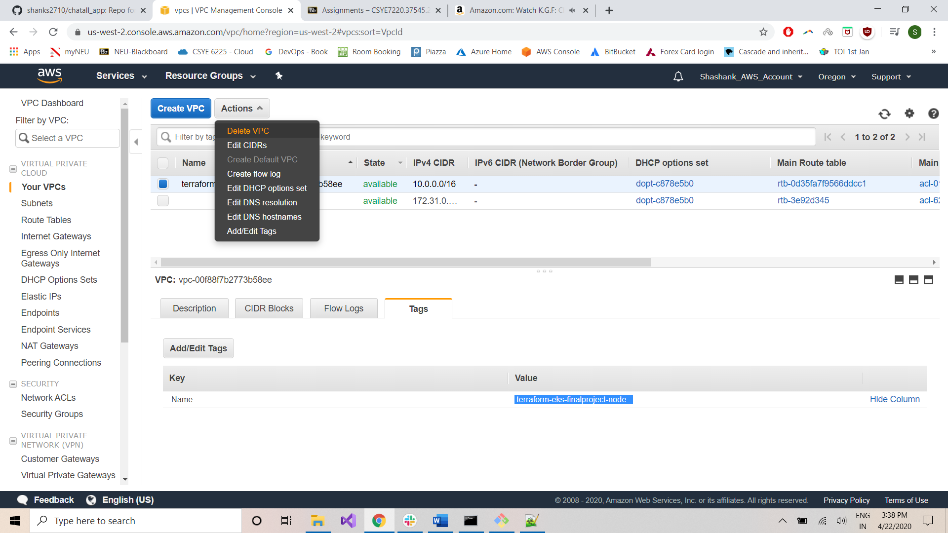

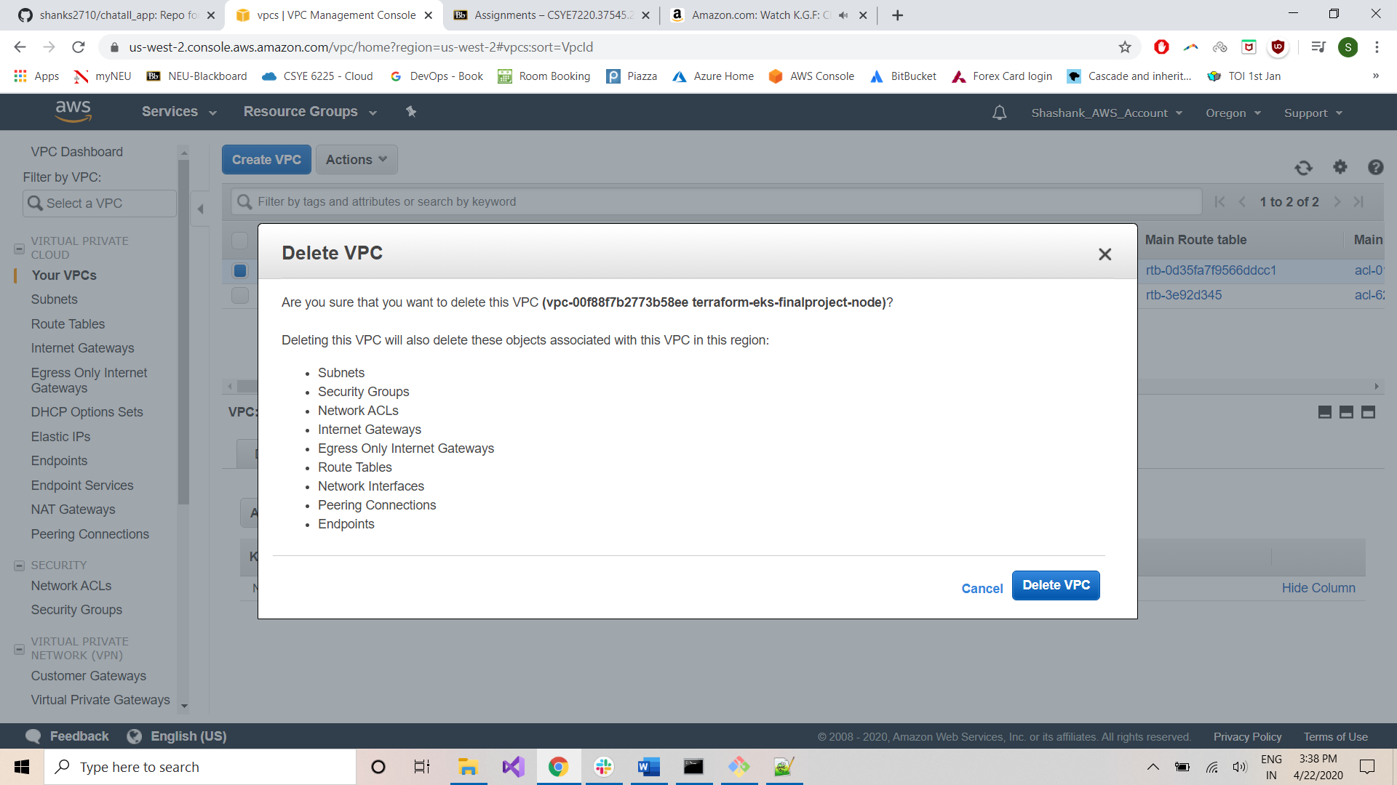

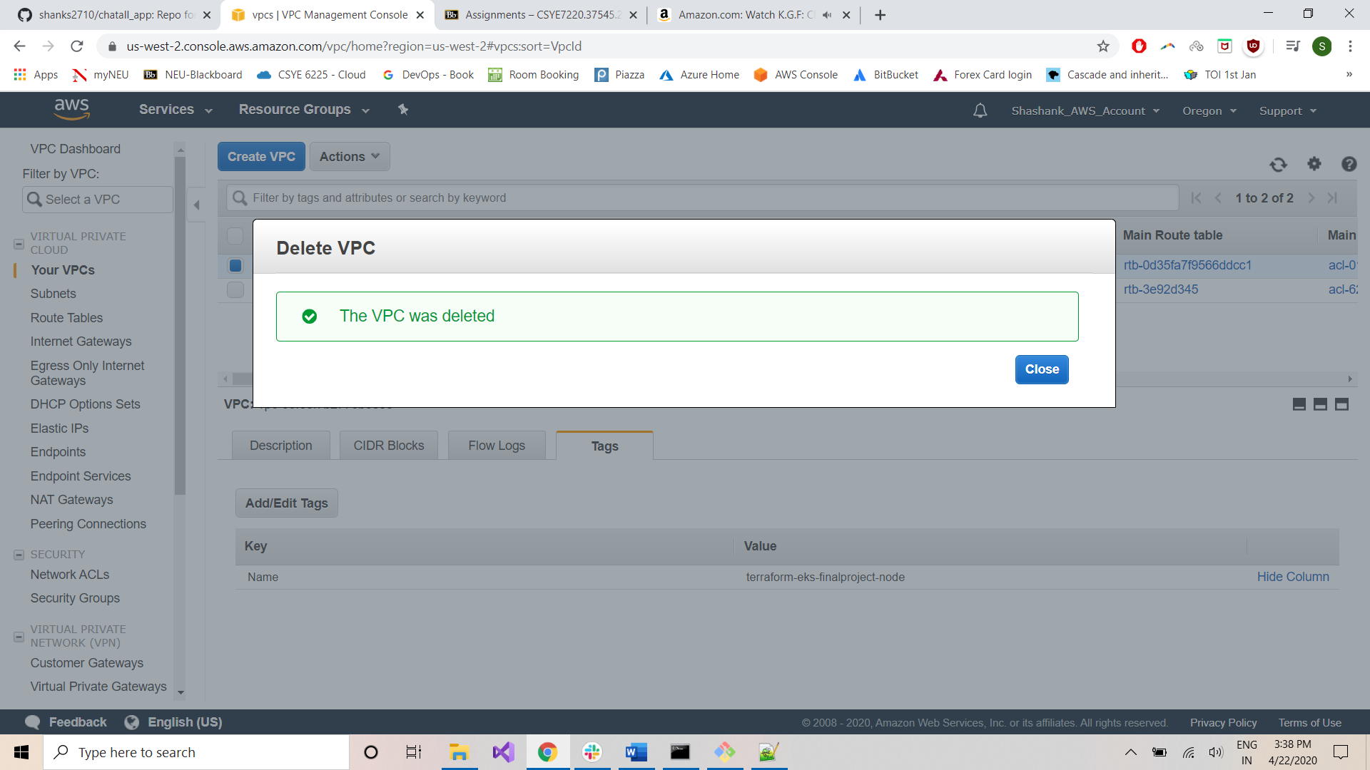

Congratulations!!! All resources have been reclaimed!!!

Enjoy!!!